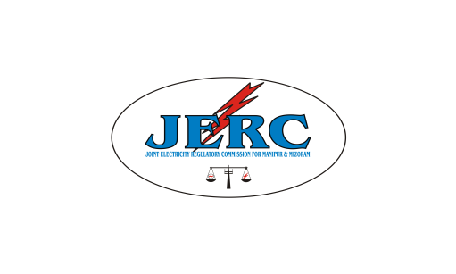

JOINT ELECTRICITY REGULATORY COMMISSION

FOR MANIPUR AND MIZORAM
AIZAWL : : : MIZORAM

TBL Bhawan, 2nd – 5th Floor, E – 18, Peter Street, Khatla, Aizawl, Mizoram-796001

Tel. No. : 0389-2336555 / 2335625, Fax: 0389-2336299 / 2335523/2335625

Website : www.jerc.mizoram.gov.in , Email : jerc.mm@gmail.com

No. A. 12024/2/14-JERC/53 : Dated Aizawl, the 20th September, 2022.

ADVERTISEMENT NO.1 OF 2022
The Joint Electricity Regulatory Commission for Manipur & Mizoram, a statutory body constituted under an Act of Parliament, invites applications from eligible candidates for filling up the below mentioned post on deputation on foreign service terms from the employees of Central/State Governments, Public Sector Undertakings, Autonomous Bodies, Universities, Recognised Research Institutions, etc. for a period of three (3) years.
Sl.No | Name of Post | Scale of Pay | No.of vacant post (s)
1 | Assistant Chief (Engineering) | Level 11 (Rs.67,700 – 2,08,700) | 1
The application shall be addressed to the Secretary, JERC (M&M), TBL Bhawan, 2nd – 5th Floor, E-18, Peter’s Street, Khatla, Aizawl, Mizoram – 796001 and will be received upto 4/11/2022 Applications received after the above specified date will summarily be rejected.
The application must be submitted through proper channel in the prescribed format. Educational qualification, experience, qualifying service, general terms and conditions of deputation can be seen at the Commission’s Website www.jerc.mozoram.gov.in. The sponsoring authorities are requested to forward the applications of eligible candidates whose service can be spared in the event of their selection. While forwarding applications, attested copies of last 5 (five) years ACR’s/PAR’s of the concerned candidates may also be enclosed in a sealed envelope along with Vigilance Clearance from Competent Authority.

Sd/-Secretary
_______________________________________________________________________________________________
Memo No. . A. 12024/2/14-JERC/53 : Dated Aizawl, the 20th September, 2022.
Copy to:
- The Senior PPS to Secretary (power), Ministry of Power, Government of India, New Delhi.
- The Chief Secretary, Government of Manipur/Mizoram for kind information. A copy of the complete advertisement is enclosed for circulation to the concerned department under them.
- Editor, Employment News, East Block-IV, Level-5, R.K.Puram, New Delhi-110066 for publication of the advertisement in his paper for 2 (two) issue on or before 14/10/2022 in the size if 3 columns x 9 cms. Bills in duplicate may be submitted to this Commission for payment.
- Editor, Vanglaini/Highlander, Aizawl-796001 for publication in his daily for 2 (two) days issue on or before 14/10/2022 In the size of 3 columns x 9 cms. Bills in duplicate may be submitted to his Commission for payment.
- Editor, Poknapham, Keisampat Thiyam Leirak, Imphal – 795001 for publication in his daily for 2 (two) days issue on or before 14/10/2022 In the size of 3 columns x 9 cms. Bills in duplicate may be submitted to his Commission for payment.
- Editor, Sangai Express, Sega Road Thouda Bhabok Leikai, Imphal, Manipur-795001 for publication in his daily for 2 (two) days issue on or before 14/10/2022 in the size of 3 columns x 9 cms. Bills in duplicate may be submitted to his Commission for payment.
- All Secretaries, State Electricity Regulatory Commission for kind information. A copy of the complete advertisement is enclosed for circulation to all Officers in their respective Commission.
- The Registrar, Mizoram University/Manipur University for kind information. A copy of the complete advertisement is enclosed with the request for wide circulation to affiliated and recognized Research Institutions and to all eligible officers under their respective Institutions.
- The Secretary, Central Electricity Regulatory Commission, 3rd and 4th Floor, Chanderlok Building, 36, Janpath, New Delhi-110001 for kind information. A copy of the complete advertisement is enclosed for circulation to all officers in their Commission.
- Notice Board of the Commission.

Sd/- RICHARD ZOTHANKIMA
Secretary

