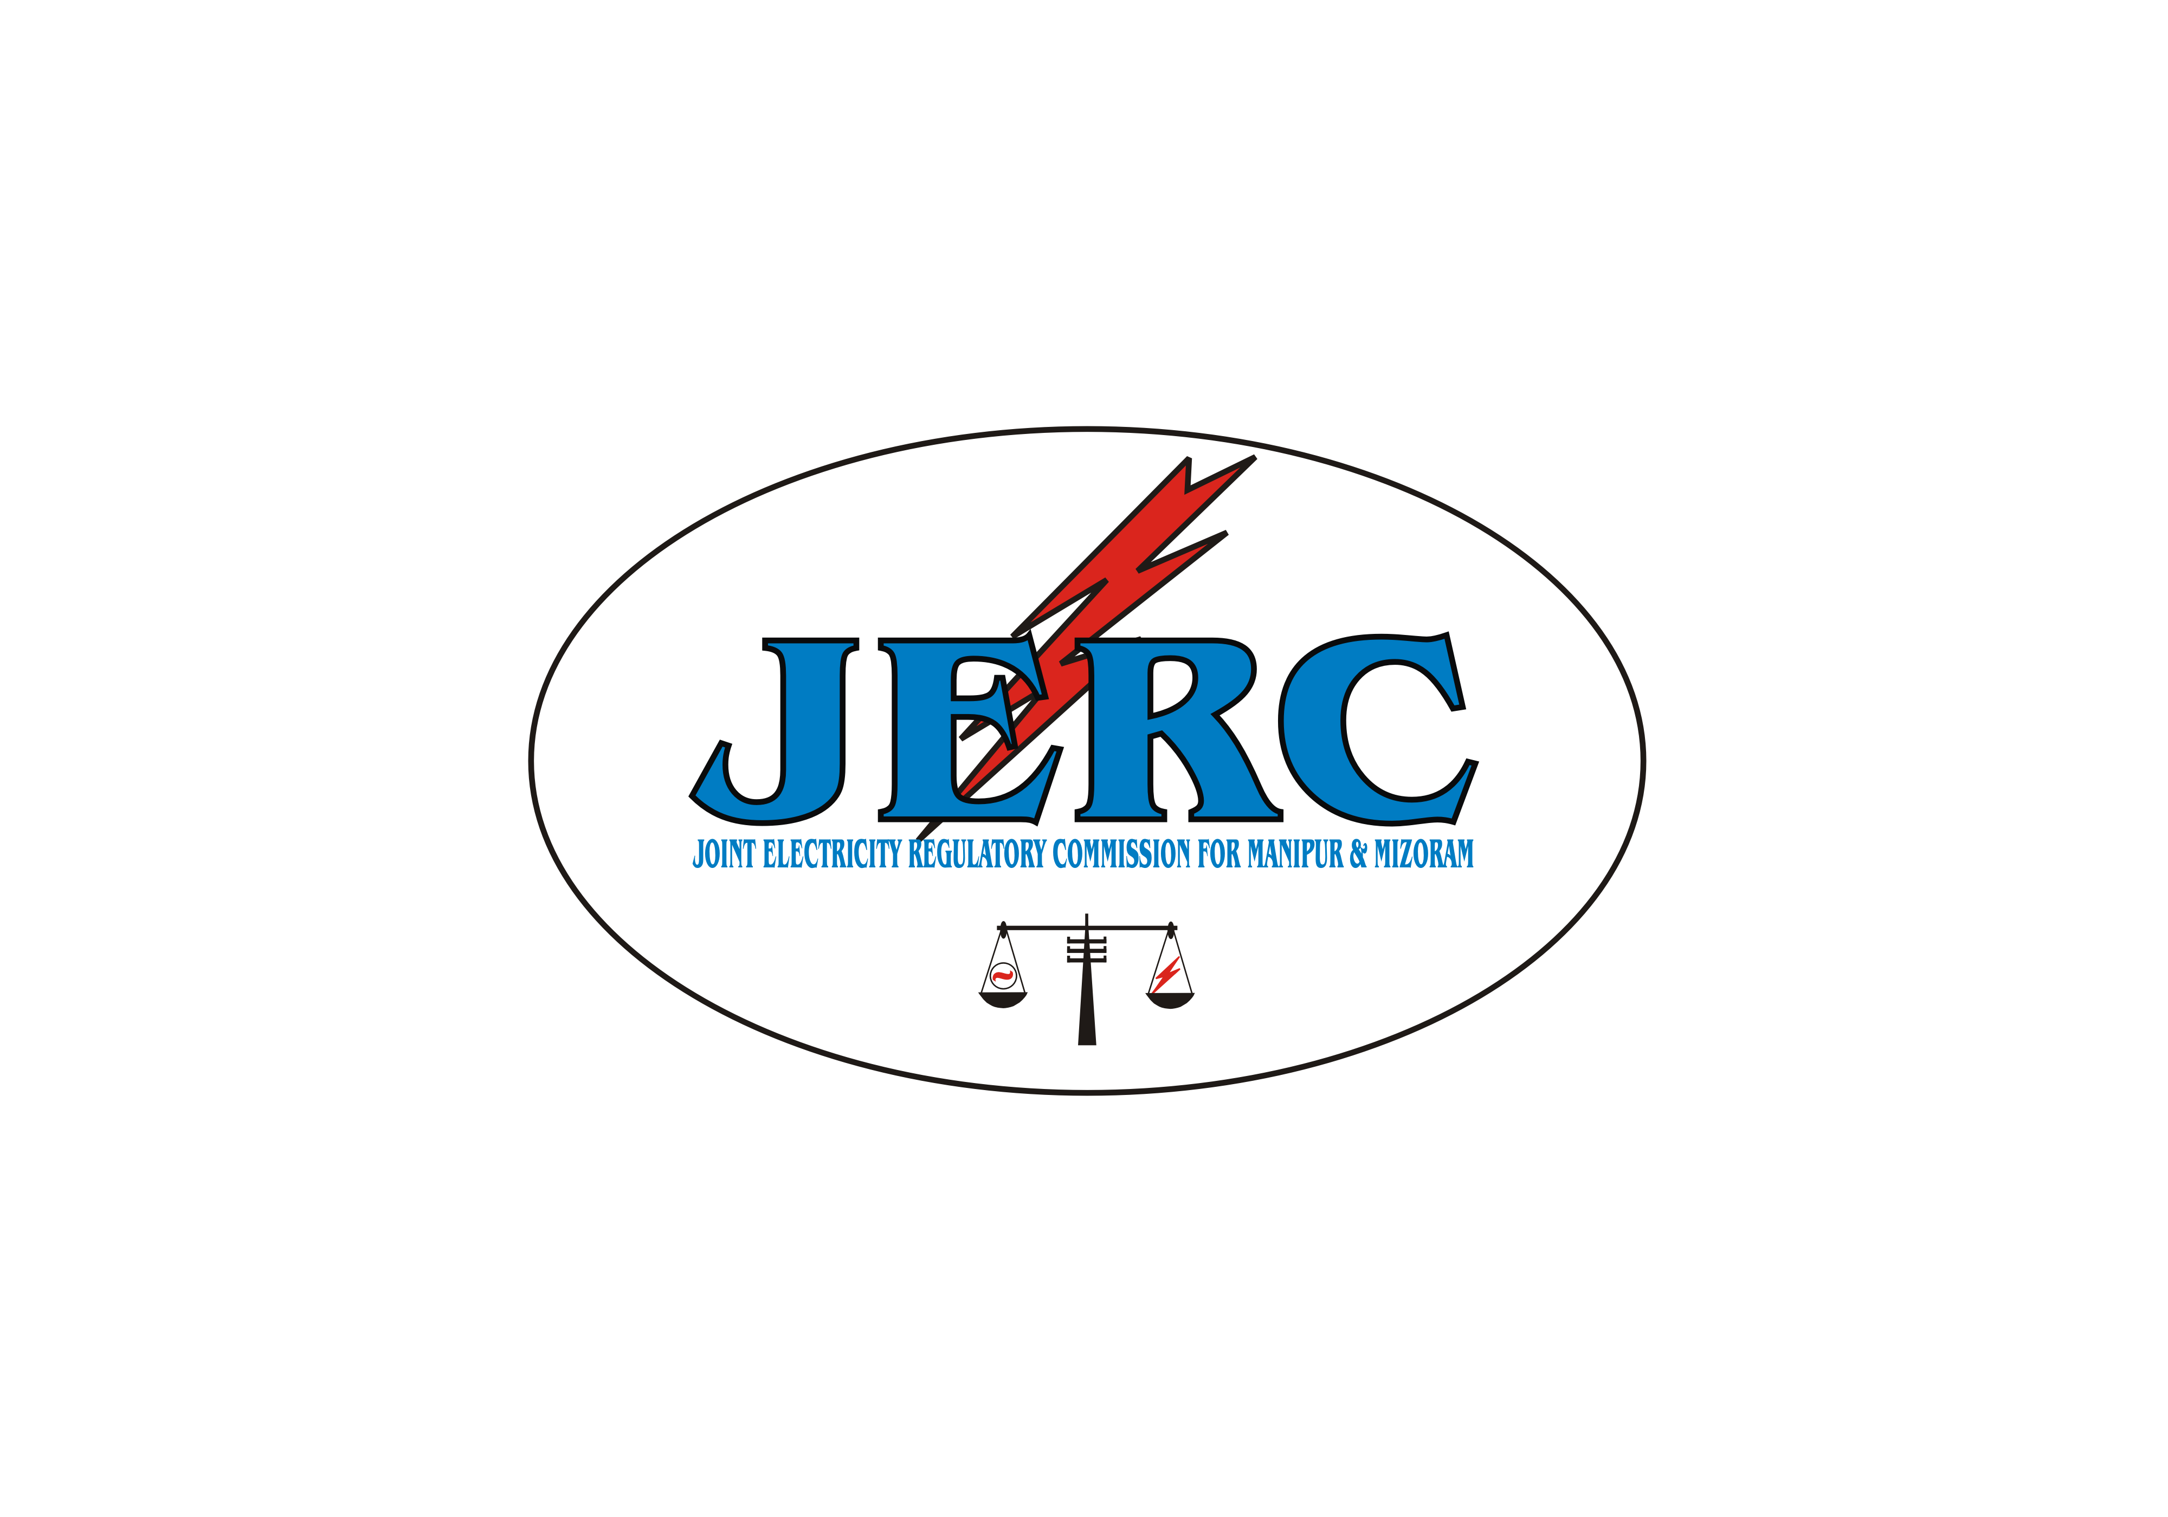
JOINT ELECTRICITY REGULATORY COMMISSION

FOR MANIPUR AND MIZORAM
AIZAWL : : : MIZORAM

D-31, M.G.Road, Upper Khatla
Aizawl,Mizoram-796001
Tel. No. : 0389-2310623
Fax: 0389-2301299
Website: www.jerc.mizoram.gov.in
Email: jerc.mm@gmail.com

NO.H.11019/17/09-JERC Dated Aizawl, the 1st April, 2010.

MINUTES OF THE 3rd MEETING OF THE STATE ADVISORY COMMITTEE FOR THE STATE OF MANIPUR HELD ON 17th MARCH, 2010
AT HOTEL CLASSIC, NORTH AOC, IMPHAL

List of the Members present is appended:

The 3rd Meeting of the State Advisory Committee for the State of Manipur was held on 17th March, 2010 at the Hotel Classic, North A.O.C., Imphal, Manipur under the Chairmanship of Mr. H. Bihari Singh, Chairperson, JERC for M & M.

The State level meeting which was attended among others by prominent Members representing the District Authorities of the State, began with a brief welcome speech by Mr. C. Hmingthanzuala, IAS (Retd), Member JERC for M&M. While welcoming the Members and other invitees, the Member JERC (M&M) also narrated briefly the important role being played by the SAC in resolving issues facing the power sector in the State and therefore, requested all the Members to participate actively in the deliberation and offer valuable suggestions that would help the Department improve its performance. Thereafter the agenda – wise discussions as per the Agenda Note which was already made available to all of the Members in advance were initiated.

Agenda 1. Confirmation of the Minutes of the 2nd Meeting of State Advisory Committee held on 9th Nov. 2009, at Circuit House Imphal:
With the consent of the Members present, the Minutes of the 2nd Meeting was confirmed without any change.

Agenda 2. Development of Renewable Energy (RE) Resources for Generation of Power:

The Chairman briefly explained the importance of non-fossil based energy over the fossil based one and emphasized the need for development of RE Sources at a large scale keeping in view the emerging energy security challenge, the burning issues of climate change and the national target generation from RE Sources. The Chairman therefore, expressed the desire to know about the preparations undertaken by the Manipur Renewable Energy Development Agency (MANIREDA) to handle such voluminous work involving diversified technologies, and also informed that a minimum level of energy to be procurred from the RE Sources by the State distribution licensees will be fixed by JERC (M&M).

Shri Y. Kholchandra Singh, Sr. Scientific Officer (SSO) MANIREDA, briefly explained about the achievements made so far by MANIREDA in the development of RE Resources for generation of Power in the State, as given below:

- 7 Nos. of Wind Solar Hybrid Power Project, each having a capacity of 10 KW (i.e. Solar – 5 KW and Wind – 5 KW) are in operation at 7 different places of the State.
- 3 Nos. of Pico Hydel Project, each having a capacity of 5 KW, are also under operation under Small Hydro Power (SHP) Development Programme.
- Three thousands of Solar Home Lighting Systems and Seven thousands Solar lanterns have been distributed to far flung villages of the State which are not connected to the State Grid, under Remote Village Electrification (RVE) through solar.
- 3 (three) Biomass gasifiers of 200 KW Capacity each at Tora, Damdei and Songtal are in operation.

In addition, MANIREDA has been taking up 7 Nos. of new schemes at different sites to harness the wind potential under Wind Energy Development Programme. Proposal for installation of 1 MW Solar Power Generation at a suitable location is being made soon.

Two more New Micro Hydel Projects of 20 KW capacity each and R&M of 2x200KW at Gelnel Mini Hydel Project have also been taken up under SHP Development Programme. Electrification of more villages under RVE through solar and installation of solar street lamps at various official complex & locations have also been proposed for implementation during the current Plan period.

Officials of MANIREDA also informed the Members that Imphal has been identified and chosen as one of the Solar Cities of the country and for that follow up actions have been initiated already by different agencies of the State including MANIREDA which would provide only the technical support to the implementation process.

Shri R. K. Dinesh Singh, IAS, D.C. (Thoubal) suggested that there should be adequate incentives to the Renewable Energy Generators for promotion of this sector. The Chairman SAC clarified that MNRE has a number of incentive schemes, like Capital subsidy, Tax exemption, Debt at lower interest rates etc.

On a query from the Chairman about the metering of the energy and payment of consumption charges by the consumers who are given power supply by MANIREDA, it was intimated that MANIREDA has not introduced so far any kind of metering arrangement and collection of consumption charges from the consumers on these promotional schemes (or demonstration projects) to which the consumers also have substantially contributed. The Chairman SAC desired that installations of 5 KW and above are metered and consumptions of those below 5 KW are assessed even if the schemes are implemented as demonstration projects.

The State policy for implementation of Renewable Energy Generation was placed before State Advisory Committee Meeting. As per the policy MANIREDA is the State Nodal Agency and is solely responsible for development of Renewable Energy Generations in the State. The National Action Plan on Climate Change (NAPCC) recommends 15% of share of Renewable Energy by 2020. To achieve this National target, the Members recommended that the investment in the State Renewable Energy Generations are to be enhanced and capacity building of the implementing agencies are planned.

After deliberations at length, the State Advisory Committee (SAC) decided to offer the following recommendations.

Recommendations:

- The State Nodal Agency (MANIREDA) shall act as a bonafide commercial generator of power from RE Sources. Necessary actions for restructuring and strengthening may be initiated.
- More matching fund may be provided based on the progress and performance of the projects.
- Investigation of more SHP schemes may be carried out keeping in view the huge potential available in the State and also the changing scenario in the power development trend.

Agenda 3: Establishment of State Load Despatch Centre(SLDC):

With reference to the mandates of the EA 2003, the Chairman briefly narrated the unbiased functions of SLDC and the importance of setting it up as an independent establishment under the State Government. The role of an independent SLDC shall become more significant and necessary when purchase of power from RE sources to meet the mandatory Renewable Purchase Obligation (RPO) of the State is introduced and for establishing a competitive Electricity market in the State.

Mr. C. Hmingthanzuala, IAS (Retd) Member, JERC also added that independent and unbiased functions of SLDC are essential while discharging various activities.

Replying to a question about the preparation of Regulations for the establishment of the SLDC, the Chairman made it clear that, SLDC is to be constituted by the State Government under Section 31(1) for discharging the prescribed functions of the SLDC under Section 32. No regulations is made for such establishment. The fees and charges may however be prescribed by the Commission.

Shri R. K. Kishore Singh, Addl. Chief Engineer, stated that the present system of operation of SLDC, which works under the Transmission Circle of the Department is purely manual control, and therefore, a proposal has been submitted to the Government for engagement of PGCIL as consultant for establishment of a full fledged SLDC with SCADA system. The requisite Administrative Approval and Expenditure sanction of the Government are awaited – the Addl. Chief Engineer added.

All the Members of the SAC were unanimous that functional independence is what is really essential for the SLDC and if it is maintained, the present arrangement can continue to work till it attains self sustenance with the fees and charges being realized from the utilities on the basis of energy transacted through it.

Recommendations:

The State Government may make arrangement for establishment of an independent full fledged SLDC for the State at an early date. Meanwhile, the functional independence of the existing SLDC may be assured.

Agenda 4. Conservation of Energy:

The way the energy conservation helps both the utility and the consumer in terms of energy and money, was briefly highlighted to the SAC by the Chairman. Keeping aside other bigger steps like Demand Side Management, schemes for loss reduction, Dos and Don’ts for energy conservation, the Chairman stressed the need to use Compact Flourescent Lamps (CFL) which give equal or more amount of light at less consumption of power in the Government owned buildings and lighting arrangements. The Chairman further suggested to introduce CFL and establish economic and efficient use of electricity in a big way as one of the easiest way of conservation of energy.

Mr. C. Hmingthanzuala, IAS (Retd), Member, JERC felt that the Department needs to design a mechanism with which the consumers can be shown the proven advantages and convinced so that they go themselves for new CFL at a time when they need replacement of old lamps or new installation.

Shri R.K. Kishore Singh, Additional Chief Engineer, Electricity Department, informed the SAC that these energy conservation matters are looked after by a State Designated Agency (SDA) that works in co-ordination with the Electrical Inspectorate. Therefore, SDA could be entrusted with the responsibility to carry out more detailed economic studies of the proposal in the larger interest of the State.

Shri R.K. Dinesh Singh, IAS, D.C. (Thoubal) pointed out that Light Emitting Diodes (LED) are extensively used in most of the countries around the world and LED is almost replacing the CFL in every installations proving its various advantages over the CFL and conventional ones. The Member further wanted that the economic study also covers LED in the interest of the consumers.

All the Members of the SAC were delighted by the deliberations on the new innovations which would help them save both the energy & the money at the critical hours.

Recommendations:

The SDA shall be requested to come up with more details about the economic and efficient use of the CFL & the LED and suggest pragmatic approach that ensures mass use of economic lamps in the State in the next meeting.

Agenda-5: Power Sector Reforms with Special Reference to Corporatisation/ Franchisee:

Initiating the discussion on Corporatisation of the Electricity Department, the Chairman drew the attention of the Members to the two vital areas namely high rate AT&C loss and the large gap between the demand and supply that causes unabated load shedding in the State, where the department has apparently left much to be desired.

Citing examples of the States where the Corportisation has helped to a great extent, the Chairman placed before the Committee the options of Corportisation, Public-Private Partnership (PPP) and franchisee of the Power Sector that are strongly recommended by the Government of India for introduction under the above situations, for consideration and subsequent recommendations.

Endorsing the views of the Chairman, Mr. C. Himingthanzuala, IAS (Retd), Member, Joint Electricity Regulatory Commission expressed the desire to refer to the Report of the ASCI on the Power Sector Reform of the Electricity Department and also to know the action initiated on it so far.

Participating in the discussion, Shri R.K. Kishore Singh, Addl. Chief Engineer, Electricity Department, informed the SAC that the proposal for Corporatisation of the Electricity Department has been appreciated by the State Cabinet, and based on it, the Government has accorded approval on 28th January, 2009. However, the process may take some more time as it is required to examine various aspects including financial implications.

In the matter related to the Registration of the proposed Corporation, where the Department seeks the service of a consultant, Shri N. Shyamsundar Singh, Chief (Engineering) JERC (M&M), stated that the Department must be very clear about the terms of reference before the service of a consultant is sought for.

Shri Aton singh, SE (Commercial) also informed the SAC that franchisee has been successfully introduced in two villages namely Ragailong and Namdailong where regular power supply has been assured and in return, the village authorities have taken the responsibility to collect revenue from the villagers under their respective jurisdiction. The arrangement works perfectly and as a result, the revenue have been timely received and the AT & C loss rate has been considerably reduced in those areas – the Additional CE added.

The Chairman was however quick to react to the assertion of the Department by putting a query on the legal validity and the authority that permits such collection of revenue. In reply, the Addl. CE informed that it is a kind of arrangement made through mutual understanding between the Department and the village authority as pilot projects – not formally authorized. Shri R. K. Dinesh Singh, IAS, D.C. (Thoubal) encouraged the steps taken by the Electricity Department. The Chairman SAC desired that such steps are required to be formalized under a specific policy decision of the Government.

The Chief (Engineering), JERC (M&M), also wanted to know from the Department officials if the Department could be ready to accept when similar proposal comes up from any of the localities of Imphal. The reply of the Department officials on this point was not encouraging.

The Chairperson JERC (M&M) reiterated that all the power projects are capital intensive and the State may not receive adequate fund for its development from the Central Government out of grant or subsidies. Under the existing arrangement, it may be difficult to check the increasing trend of AT&C losses and to supply electricity to the consumers at a cheaper rate. Therefore, the State should follow the power reform process and allow corporations/ franchisees to act at selected areas as early as possible – the Chairman expressed concern.

Recommendation:

(A) The State Government shall endeavour Corporatisation as early as possible. Pending Corporatisation, the Electricity Department shall make an all out effort to improve the efficiency of the Department and make its performance accountable by reducing AT & C loss as well as the pro-rata shedding in the shedding.

Agenda 6. Presentation of Electricity Department on Power Scenario of Manipur:

The Members of the SAC got definitely disappointed when the Electricity Department expressed its inability to present a power point presentation on State’s Power Scenario. Instead, a hard copy of the brief power scenario of the State was made available to the Committee.

Some of the important points are reproduced below for information & record.

- Total number of Consumers as on February, 2010 is 1,87,046.
- Power consumption in the valley is 83.19% while in the hill it is only 16.81%.
- Load Shedding is unavoidable. Power supply is available only for 3 hrs in the day time and 5 hrs (5 pm to 10 pm) and 2 hrs (10 pm to 12 midnight) alternately in the evening/ night time.
- The AT & C losses of the Department is maximum in the country.
- Peak load (Night) and Off-peak load (Day) shortages during lean season are 44% and 53% respectively.

Agenda 7. Review of the progress made by the Electricity Department on the earlier recommendations in respect, (1) Power Generation and Continuity of Power Supply, (2) Metering & Billing:

A. Recommendations in the 1st State Advisory Committee Meeting.

- It was informed that project parameters and benefits of the major Hydel Projects have already been published in local dailies.
- Inclusion of Director/ MANIREDA as a Member of the Committee is under consideration.
- Apparently, the Electricity Department has superficial knowledge about the present status.
- The Electricity Department has once again failed to come up with a load forecast and its corresponding procurement planning.
- As per the latest report furnished, the Department has completed only 20% metering as on February, 2010
- Despite efforts by the Department, there has been no significant change in the number of consumers. More than 40% of the consumers are apparently not registered. The CE, JERC suggested that the sub-families of a Undivided Hindu Family (UHF) which have separate installations are also registered as individual consumers and provided separate meters.
- Improvement in the Billing process was not reflected anywhere.

B. Recommendations in the 2nd State Advisory Committee Meeting.

- The Green paper which was submitted to the Commission earlier, does not provide the kind of information/ data which it is supposed to contain for discussion in the SAC Meeting. The approach is simply narration not engineering, and it has been prepared without much exercise and application of mind. Therefore, it does not spell out how it likes SAC to react and help the Department out. In fact, the Department has been saying so many things but not telling anything – the Members remarked.

Shri R. K. Kishore Singh, Addl. Chief Engineer, assured that an improved Green paper would be submitted soon to the Commission for further discussions.

- Improvement in the Power Supply was not done.

The Members of the SAC would like to have further discussion on these issues in the next Meeting.

Agenda 8. Miscellaneous:

Shri S. Chaothoi Singh, President, Manipur Industries Union informed that the Japanese Government is ready to extend financial support to viable projects in Manipur. He suggested that we may propose to the Japanese Government one or two medium scale Hydro Power Projects for direct funding or through Government of India. The Members were of the opinion that availing loan/ grant for implementation of schemes is a policy matter of the Government and therefore, it is beyond the purview of the State Advisory Committee.

The Meeting ended at 2:00 pm with vote of thanks to the Chair.

Sd/- H. Bihari Singh
Chairman
State Advisory Committee Manipur

Memo No.H.11019/16/09-JERC : Dated Aizawl, the 1st April, 2010.

Copy to:
- PS to Hon’ble Minister, Electricity Deptt., Govt. of Manipur, Imphal for kind information of the Hon’ble Minister (Power).

- PPS to Chief Secretary, Govt. of Manipur, Imphal for kind information of the Chief Secretary, Manipur.

- PS to Principal Secretary (Power), Govt. of Manipur for information of the Prinicipal Secretary (Power).

- All Members of the State Advisory Committee of Manipur.

- Guard File.

(RICHARD ZOTHANKIMA)
Assistant Secretary
Joint Electricity Regulatory Commission for Manipur and Mizoram

3rd MEETING OF THE STATE ADVISORY COMMITTEE OF MANIPUR

List of Members and Invitees Present:

A. MEMBERS:

1. Mr. H. Bihari Singh, - Ex-officio Chairman
Chairman, JERC for Manipur & Mizoram.

2. Mr. C. Hmingthanzuala, IAS (Retd.), - Ex-officio Member

3. Mr. R.K. Dinesh Singh, IAS, D.C. - Member
Thoubal District, Manipur.

4. Dr. Nivedita Devi, AC - Member
for DC, Imphal East District.

5. Mr. K. Thansang, ADC - Member
for DC, Churachanpur District.

6. Mr. W. Manglem, President, - Member
Consumers Club, Manipur.

7. Mr. S. Chaothoi Singh, President, - Member
Manipur Industries Union, Imphal.

8. Mr. Richard Zothankima, - Member Secretary
Assistant Secretary, for Secretary,
JERC for Manipur & Mizoram.

B. SPECIAL INVITEES:

1. Mr. R. K. Kishore Singh, Addl. CE (Power),
for CE (Power), Govt. of Manipur.

2. Mr. Y. Kholchandra Singh, Sr. S.O.
for Director, MANIREDA, Manipur.

C. INVITEES:

1. Mr. N. Shyamsundar Singh, Chief (Engineering),
JERC for Manipur & Mizoram.

2. Mr. Lalhminghlua, Assistant Chief (Engineering),
JERC for Manipur & Mizoram.

