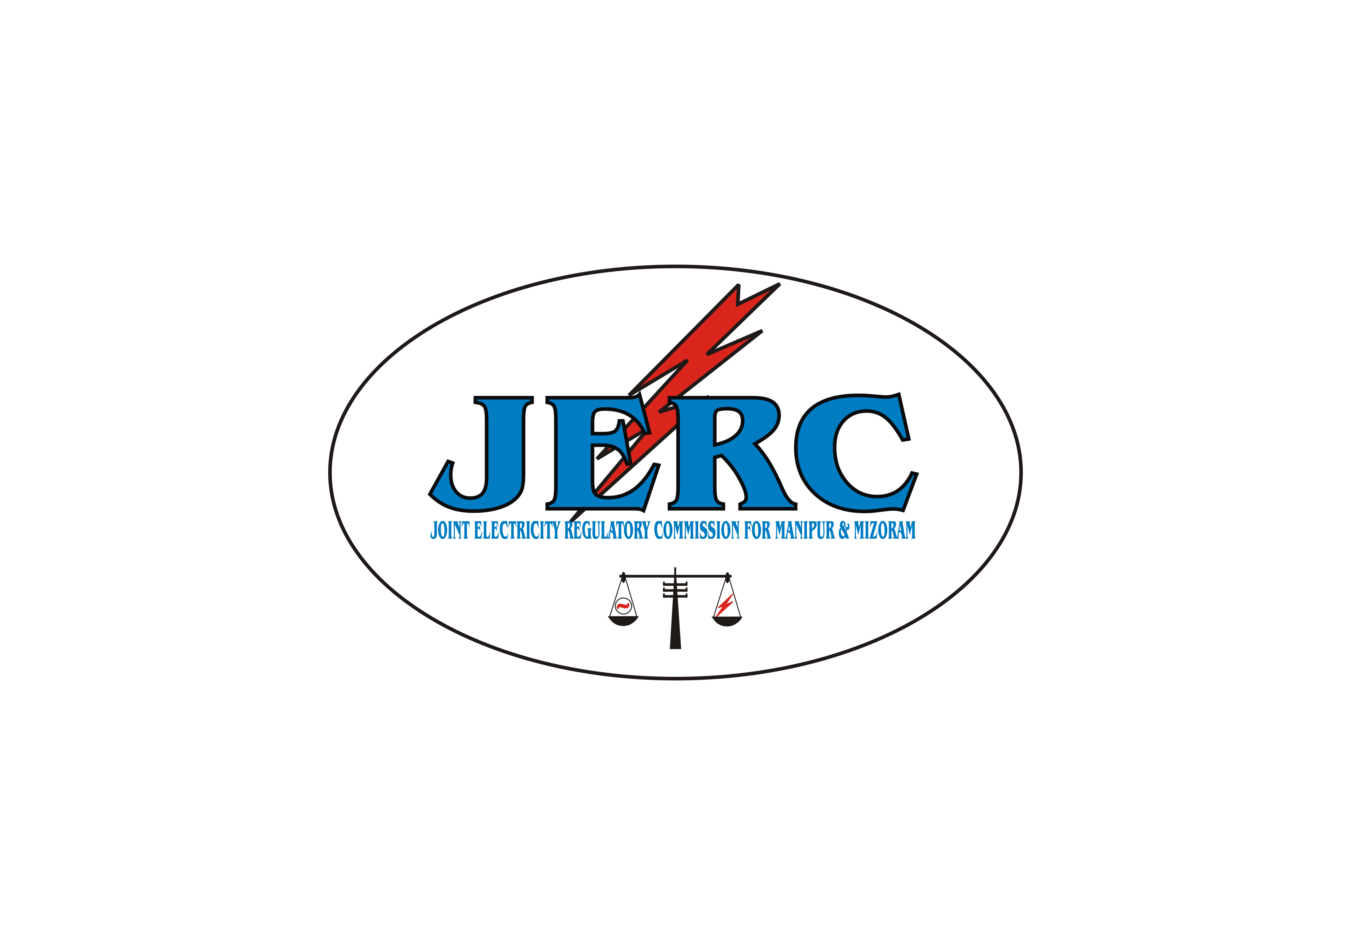
JOINT ELECTRICITY REGULATORY COMMISSION
FOR THE STATES OF MANIPUR & MIZORAM

N O T I F I C A T I O N

No. H. 13011/5/09-JERC Dated Aizawl, the 5th May, 2010. In exercise of powers conferred under sections 61, 66, 86(1) (e) and 181 of the Electricity Act, 2003 and all other powers enabling it in this behalf, the Joint Electricity Regulatory Commission for the States of Manipur & Mizoram hereby makes the following regulations for the Renewable Purchase Obligation and its Compliance through promotion of generation & purchase of power from renewable sources at specified tariff.

I Short title, commencement and extent
(1) These regulations may be called the Joint Electricity Regulatory Commission for the States of Manipur & Mizoram (Renewable Purchase Obligation and its Compliance) Regulations, 2010.

(2) These Regulations shall come into force from the date of their publication in the Official Gazette of Manipur and Mizoram

- These Regulations shall extend to the whole of the States of Manipur and Mizoram and shall apply in relation to all matters falling within the jurisdiction of the Commission.

II Definitions and Interpretation:
(1) In these Regulations, unless the context otherwise requires,
(a) “Act” means the Electricity Act, 2003 (36 of 2003);
(b) “Central Agency” means the agency operating the National Load Dispatch Centre or such other agency as the Central Commission may designate from time to time
(c) “Central Commission” means the Central Electricity Regulatory Commission referred to in sub‐section (1) of section 76 of the Act;

(d) “Certificate” means the renewable energy certificate issued by the Central Agency in accordance with the procedures prescribed by it and under the provisions specified in the Central Electricity Regulatory Commission (Terms and Conditions for recognition and issuance of Renewable Energy Certificate for Renewable Energy Generation) Regulations, 2010;
(e) “Cogeneration” means a process, which simultaneously produces two or more forms of useful energy (including Electricity);
(f) “Commission” means the Joint Electricity Regulatory commission for the States of Manipur and Mizoram;
(g) “Eligible Entity” means the entity eligible to receive the certificates under these Regulations;
(h) “Forbearance Price” means the ceiling price as determined by the Central Commission in accordance with the Central Electricity Regulatory Commission (Terms and Conditions for recognition and issue of Renewable energy Certificate for Renewable Energy Generation) Regulations, 2010, as amended from time to time, within which only the Certificate can be dealt in power exchange;
(i) “Interconnection facilities” means all the facilities which shall include, without limitation, switching equipment, control, protection and metering devices etc. for the incoming bay(s) for the project(s), to be installed and maintained by the licensee at the Inter-Connection Point at the cost of the generator to enable evacuation of electrical output from the Project;
(j) “Interconnection Point” means the physical touch point where the project line(s) and the allied equipment forming a part of the interconnection facilities are connected to the licensee’s power system;
(k) “MNRE” means the Ministry of New and Renewable Energy;
(l) “Obligated Entity” means the distribution licensee, consumer owning the captive power plants and open access consumer in the state of Manipur/Mizoram, which is mandated to fulfill renewable purchase obligation under these Regulations;
(m) “Person” shall include any company or body corporate or association or body of individuals, whether incorporated or not, or artificial juridical person;
(n) “Power Exchange” means any exchange operating as the power exchange for electricity in terms of the orders issued by the Central Commission;

(o) “Preferential Tariff” means the tariff fixed by the Joint Electricity Regulatory Commission for the States of Manipur and Mizoram for sale of energy from a generating station based on renewable energy sources to a distribution licensee;
(p) “Project Line(s)” means the transmission line(s) from the generating station to the interconnection point which shall be constructed, operated and maintained as a part of the project by the generator, but shall not include the inter-connection facilities;
(q) “Renewable Energy Sources” means renewable sources such as small hydro, wind, solar including its integration with combined cycle, biomass, bio fuel cogeneration, urban or municipal waste and such other sources as recognized or approved by MNRE;
(r) “State Agency” means the agency in the State of Manipur/Mizoram to be designated by the Joint Electricity Regulatory Commission for the States of Manipur and Mizoram to act as the agency for accreditation and recommending the renewable energy projects for registration and to undertake functions under these regulations;
(s) “Year” means a financial year.

(1I) Words and expressions used in these Regulations and not defined but defined in the Act or the regulations issued by the Central Commission or any other regulations issued by the Commission, shall have the same meaning assigned to them respectively in the Act or such regulations issued by the Central Commission or such other regulations issued by the Commission.

1 Promotion of Generation of Electricity from RE Sources
(1) Any person, public or private, generating electricity from renewable sources of energy, irrespective of installed capacity, shall have mandatory open access to any licensee’s transmission system and/ or distribution system or grid, as the case may be under the JERC for M & M (Terms and Conditions for Open Access) Regulations, 2009
(2) The minimum percentage of electrical energy which each distribution licensee shall purchase from new and renewable sources generators shall be as stipulated in the Commission’s order issued from time to time, subject to the availability of such power. The distribution licensee shall furnish the quantum of purchase of energy from new and renewable sources and cogeneration for the ensuing year in the Annual Revenue Requirement (ARR) filing.
(3) Evacuation facilities shall be provided by the State Transmission Utility (STU)/ Distribution licensee as per the JERC for M & M (Grid Code) Regulations, 2010. The cost of interfacing lines, switch gear, metering, protection arrangement and related other equipments up to the interconnection point shall have to be borne by the generators, but the work shall be executed by STU/ distribution licensee.
(4) The licensee shall provide adequate payment security mechanism to the generators for purchase of power.
(5) The licensees shall provide interconnection of the project line(s) at its nearest control sub-station;
Provided that where it is not feasible for the licensee to provide inter-connection at the nearest control sub-station, it shall propose to the generator, other feasible interconnection sub-station(s) and the said proposal, alongwith the reasons for not allowing interconnection at the nearest sub-station, shall be submitted by the licensee for approval of the Commission;
(6) Where there are right of way problems or there are space limitations at the sub-stations of the licensee or where the generator opts on his own, the generator may, with the approval of the Commission, enter into a suitable arrangement for joint project lines for two or more projects and inject power into the grid through the joint evacuation system.
(7) For evacuation of power from renewable sources and co-generation beyond the interconnection point, the licensee shall, prepare a comprehensive plan for augmenting and establishing the transmission/ sub-transmission system corresponding to the commissioning of the projects indicating therein, the year-wise time lines to match the commissioning of the project with the establishment of the related evacuation system. The plan for the projects expected to be commissioned during the subsequent years shall be prepared by the licensee at least one year in advance.
Provided that where the time lines laid down in the plan approved under this sub-regulation are not adhered to, the defaulting licensee or the generator, as the case may be, shall be liable to pay such penalty as the Commission may, after affording opportunity, impose.

(8) The plan prepared under the above sub-regulation 1(7) shall be submitted by the licensee for the approval of the Commission and any expenditure on account of such plan shall be a pass through to the licensee.
(9) The generators may, in consultation with the licensee and with the prior approval of the Commission, augment or establish, on behalf of the licensee, the transmission system beyond interconnection point, on build and transfer basis, and the expenditure so incurred by the generators shall be repaid by the licensee alongwith interest in five equal instalments, spread over a period of 5 years commencing from one year after the date of commissioning of the project, and such expenditure shall be allowed as a pass through to the licensee.

2 Renewable Purchase Obligation
(1) Minimum quantum of electricity to be purchased by the licensees from renewable energy sources, expressed as percentage of their total consumption of electricity in a year shall be as per the schedule, given below:
Renewable Purchase Obligation of Licensee
Year | RPO for Manipur | RPO for Mizorm
2010-11 | 2% | 5.0%
2011-12 | 3% | 6.0%
2012-13 | 5% | 7.0%
For subsequent years, the Commission will separately specify the purchase obligation as the Commission deems fit.
Provided that 0.25% percentage point out of the total consumption shall be procured from generation based on solar as renewable energy source only:
Provided further, such obligation to purchase renewable energy shall be inclusive of the purchases, if any, from renewable energy sources already being made by concerned obligated entity:
Also provided that the power purchases/produces by the Licensee from its own renewable energy sources shall be included in the obligation as specified hereinabove.
(2) Purchase obligation for licensee as specified above are mandatory minimum percentage of purchase to be maintained by the Licensee. The licensee shall have the option to purchase higher percentage with the prior approval of the Commission.
(3) The licensee shall indicate the proposed quantum of purchase from respective cogeneration and renewable sources of energy for a year in the ARR filing.
(4) While indicating the proposed quantum of purchase from renewable sources, the licensee shall indicate the sources from which it plans to purchase the specified quantum of purchase. The licensee, to the extent possible, shall source the proposed quantum of electricity from renewable sources within his Area of supply.
(5) In a situation where licensee is unable to purchase the required quantum within Area of supply due to shortage or non availability of such sources in any given year, to the extent of shortfall, the licensee may purchase the quantum from renewable sources outside the licensee’s area of supply and the licensee shall make best efforts to strengthen the system and provide open access to transmit power from renewable sources.
(6) While contracting power purchase from new sources, priority shall be given to the date of commercial operation of such generating stations.
(7) The Commission may review the quantum of purchase from renewable sources by a licensee once in every 3 years or at lesser intervals as may be necessary.
(8) The Commission may waive the above minimum quantum targets for the year as per clause 2(1) of this Regulation subject to supply constraints or any other uncontrollable factor in the opinion of the Commission, at the request of the licensee.
(9) The Regulations shall apply to
(1) Distribution Licensee
(2) Any other person consuming electricity of 1MW and above
(i) generated from conventional Captive Generating Plant for his own use and/or
(ii) procured from conventional generation through open access / third party sale.

3 Certificates under the Regulations of the Central Commission
(1) Subject to the terms and conditions contained in these regulations the Certificates issued under the Central Electricity Regulatory Commission (Terms and Conditions for recognition and issuance of Renewable Energy Certificate for Renewable Energy Generation) Regulations, 2010 shall be the valid instruments for the discharge of the mandatory obligations set out in these regulations for the obligated entities to purchase electricity from renewable energy sources.
Provided that in the event of the obligated entity fulfilling the renewable purchase obligation by purchase of certificates, the obligation to purchase electricity from generation based on solar as renewable energy source can be fulfilled by purchase of solar certificates only, and the obligation to purchase electricity from generation based on renewable energy other than solar can be fulfilled by purchase of non-solar certificates.
(2) Subject to such direction as the Commission may give from time to time, the obligated entity shall act consistent with the Central Electricity Regulatory Commission (Terms and Conditions for recognition and issue of Renewable Energy Certificate for Renewable Energy Generation) Regulations, 2010 notified by the Central Commission in regard to the procurement of the certificates for fulfilment of the Renewable Purchase Obligation under these regulations.
(3) The Certificates purchased by the obligated entities from the power exchange in terms of the regulation of the Central Commission mentioned in clause (1) of this Regulation shall be deposited by the obligated entities to the Commission in accordance with the detailed procedure issued by the Central Agency.

4 State Agency
(1) The Commission shall designate from time to time an agency as State Agency for accreditation and recommending the renewable energy projects for registration and to undertake functions under these regulations.
(2) The State Agency shall function in accordance with the directions issued by the Commission and shall act in consistent with the procedures rules laid by Central Agency for discharge of its functions under the Central Electricity Regulatory Commission (Terms and Conditions for recognition and issuance of Renewable Energy Certificate for Renewable Energy Generation) Regulations, 2010.
(3) The State Agency shall submit quarterly status to the Commission in respect of compliance of renewable purchase obligation by the obligated entities in the format as stipulated by the Commission and may suggest appropriate action to the Commission if required for compliance of the renewable purchase obligation.
(4) The Commission may from time to time fix the remuneration and charges payable to the State Agency for discharge of its functions under these regulations.
(5) If the Commission is satisfied that the State Agency is not able to discharge its functions satisfactorily, it may by general or special order, and by recording reasons in writing, designate any other agency to function as State Agency as it considers appropriate.

5 Determination of Tariff for electricity from Renewable sources and
Cogenerations
(1) Tariff for purchase of electricity from renewable energy sources shall be mutually agreed by the licensees and the suppliers at a level not above the price cap specified by the Commission.
(2) To facilitate examination of reasonableness of price at which a licensee shall procure energy from renewable energy sources, the prospective purchaser may require the seller to submit all cost data and financial charges to the purchaser. MOU/ PPA as agreed between the seller and the purchaser shall be submitted to the Commission. The Commission at this stage does not debar a licensee from agreeing to a negotiated price within the capped price. However, competitive price within the capped level will be the preferred alternative.
(3) In case the parties are unable to agree mutually, the matter shall be referred to the Commission by filing a petition by either or both the parties for settlement.
(4) The Commission shall determine the Tariff separately for each category of renewable source mentioned in clause II(q) as per JERC (Terms and Conditions for Tariff Determination from Renewable Energy Sources) Regulations, 2010.

Provided that the Tariff so determined by the Commission is subject to review after 5 years and such revised tariff shall be applicable to agreements entered into after that date.

6 Effect of default
(1) If the obligated entities does not fulfill the renewable purchase obligation as provided in these regulations during any year and also does not purchase the certificates, the Commission may direct the obligated entity to deposit into a separate fund, to be created and maintained by such obligated entity, such amount as the Commission may determine on the basis of the shortfall in units of RPO and the forbearance price decided by the Central Commission:
Provided that the fund so created shall be utilised, as may be directed by the Commission, for purchase of the certificates:
Provided further that the Commission may empower an officer of the State Agency to procure from the Power Exchange the required number of certificates to the extent of the shortfall in the fulfilment of the obligations, out of the amount in the fund:

Provided also that the distribution licensee shall be in breach of its licence condition if it fails to deposit the amount directed by the Commission within 15 days of the communication of the direction.
(2) Where any obligated entity fails to comply with the obligation to purchase the required percentage of power from renewable energy sources or the renewable energy certificates, it shall also be liable for penalty as may be decided by the Commission under section 142 of the Act:
Provided that in case of genuine difficulty in complying with the renewable purchase obligation because of non‐availability of certificates, the obligated entity can approach the Commission for carry forward of compliance requirement to the next year:
Provided that where the Commission has consented to the carry forward of compliance requirement, the provision of clause (2) of the Regulation or the provision of section 142 of the Act shall not be invoked.

7 Overriding Effect

Notwithstanding anything contained contrary –
- In the Joint Electricity Regulatory Commission for the States of Manipur & Mizoram (Terms and Conditions for Determination of Tariff) Regulations 2010; and
- In the JERC for M & M (Terms and Conditions for Open Access) Regulations, 2009;
framed by the Commissioned under Section 181 of the Electricity Act, 2003, these Regulations shall have overriding effect in so far as Generation & Purchase of power from RE sources is concerned.

8. Power to Remove Difficulties
If any difficulty arises in giving effect to any of the provisions of these Regulations, the Commission may, either sou moto or on an application made to it, by general or special order, direct the Licensee/ Generator or any other person to take suitable action, not being inconsistent with the Act, which appears to the Commission to be necessary or expedient for the purpose of removing the difficulty.

9 Issue of Orders and Directions
Subject to the provisions of the Act and these Regulations, the Commission may from time to time, issue orders and practice directions with regard to the implementation and matters incidental or ancillary thereto.
10 Saving of Inherent Powers of the Commission
Nothing contained in these Regulations shall limit or otherwise affect the inherent powers of the Commission to adopt a procedure, which is at variance with any of the provisions of these Regulations, if the Commission, in view of the special circumstances of the matter or class of matters and for reasons to be recorded in writing, deems it necessary or expedient to depart from the procedure specified in these Regulations.

11 Interpretation
All issues arising in relation to interpretation of these Regulations shall be determined by the Commission and the decision of the Commission on such issues shall be final.

By Order of the Commission



