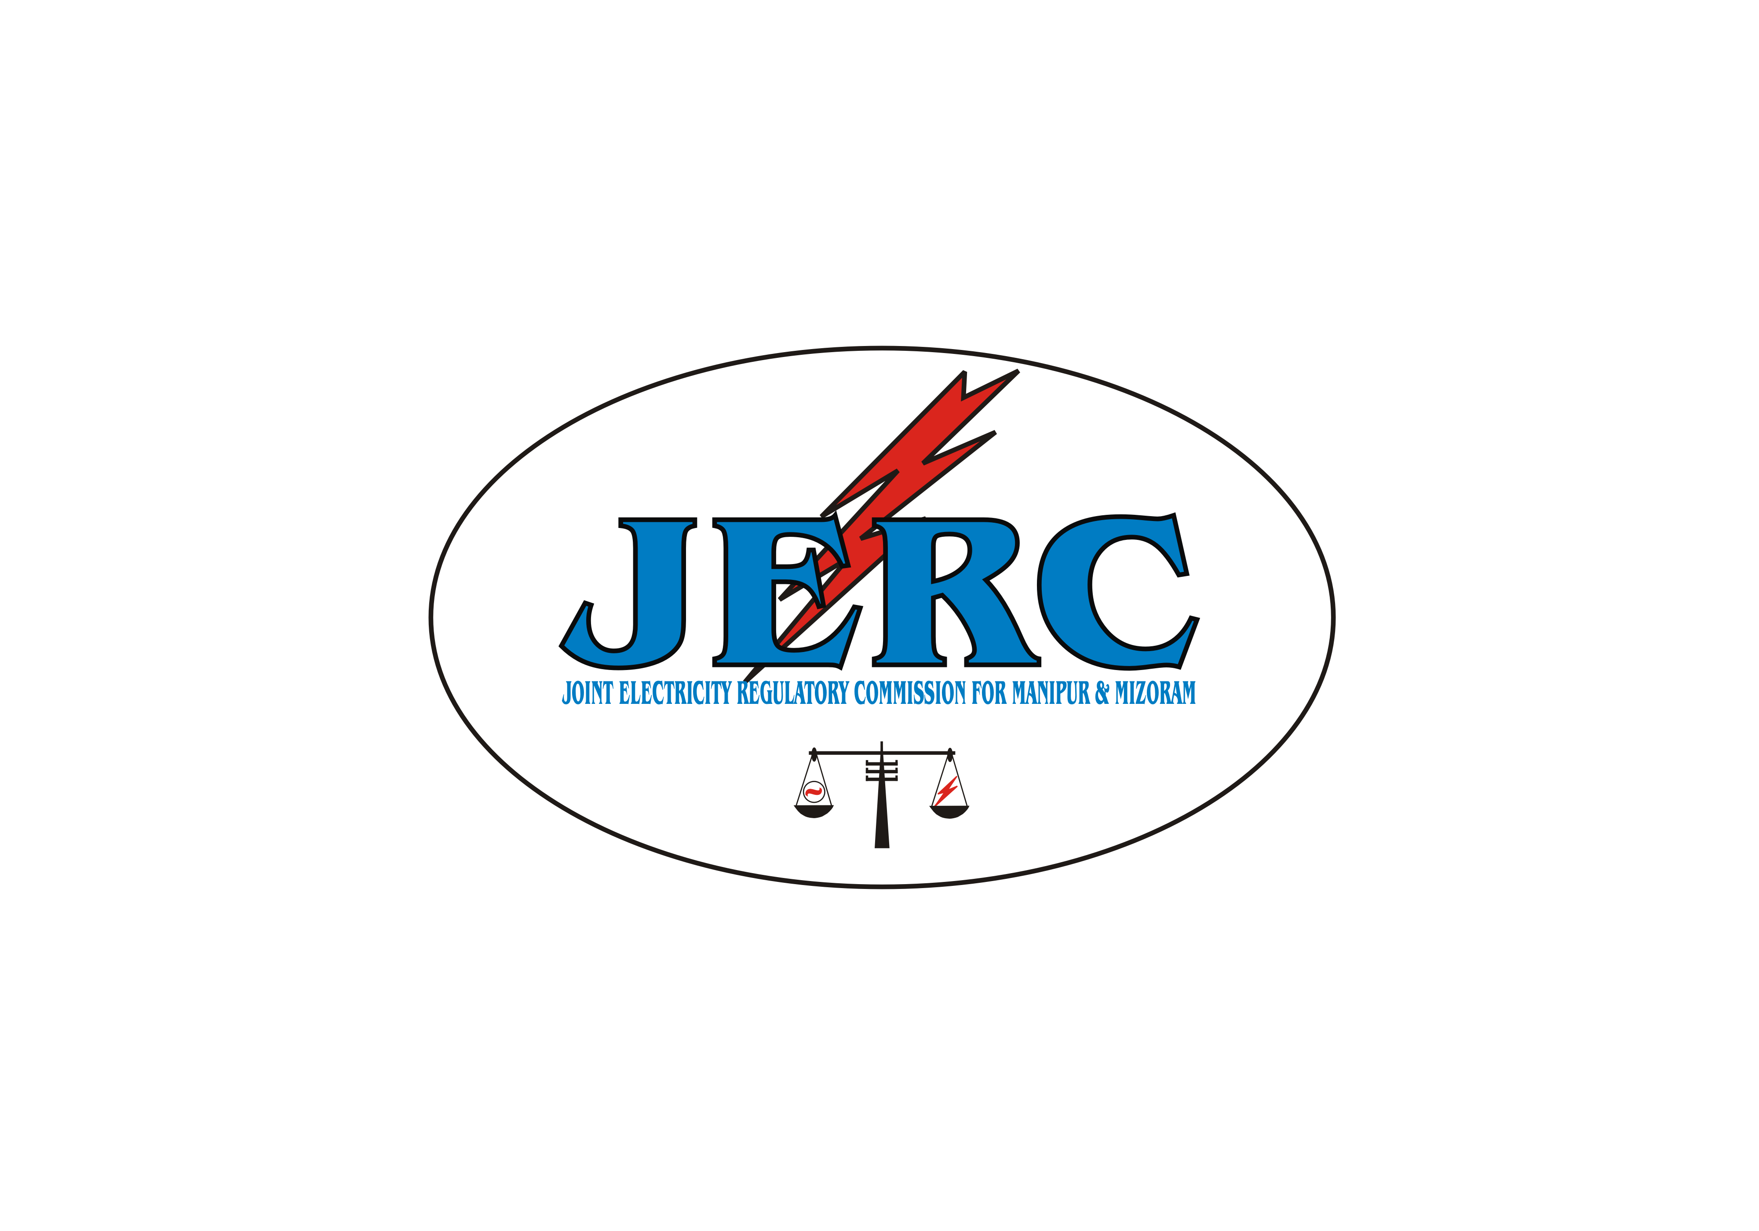

JOINT ELECTRICITY REGULATORY COMMISSION
FOR MANIPUR AND MIZORAM
AIZAWL : : : MIZORAM

TBL Bhawan, 2nd – 5th Floor, E-18, Peters Street, Khatla, Aizawl,Mizoram-796001
Fax: 0389-2336299/2335523, Tel. No. : 0389-2333625/2335625
e-mail: jerc.mm@gmail.com,Website: www.jerc,mizoram.gov.in

No. D.19015/2/16-JERC Dated Aizawl, the 7th Jan., 2021

Q U O T A T I O N

The Joint Electricity Regulatory Commission for Manipur and Mizoram invites sealed quotation from reputed firms for supply and installation of the following item in the Office of the JERC for Manipur & Mizoram.
Sl.No Items Quantity
- Printer (HP LaserJet P1108) 2 nos.

The quotation is to be addressed and received by the undersigned till 1:00 pm of dt. 15.01.2021 due to emergency case in the office at Khatla, Peter’s Street, Aizawl, Mizoram and the same will be opened on the same day at 1:30 p.m.

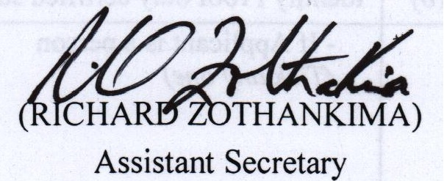
Memo No. D.19015/2/16-JERC/ : Dated Aizawl, the 7th Jan., 2021
Copy to:
- All Reputed Firms in Aizawl through telephone for kind information and necessary action as per economy measures vide O.M. No. G.17014/4/2019-FEA, dated 28 – 3-2020 issued by Govt. of Mizoram Finance Department in an effort to economic fallout of COVID-19 .
- File No. G.25017/2/17-JERC for further necessary action.
- Pu Lalramhlun Puroulte i/c JERC (M&M) website for kind necessary action to upload in the Commission’s website.
- Notice Board.
- Guard File/ Relevant Files.

Sd/-RICHARD ZOTHANKIMA

Assistant Secretary

