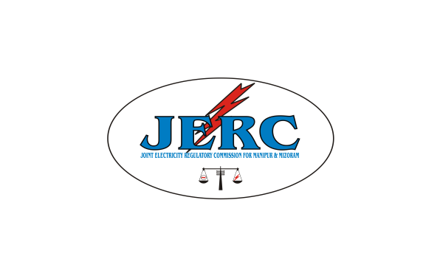
JOINT ELECTRICITY REGULATORY COMMISSION

FOR MANIPUR AND MIZORAM
AIZAWL::: MIZORAM

N O T I F I C A T I O N

Dated Aizawl, the 15th September, 2016

No.H.13011/35/16-JERC: In exercise of powers conferred under sections 61, 66, 86(1)(e) and 181 of the Electricity Act,2003(Act36 of 2003) and all other powers enabling it in this behalf, and after previous publication, the Joint Electricity Regulatory Commission for the states of Manipur and Mizoram hereby makes the following Metering regulations for grid connected Renewable Energy systems, namely:

1. SHORT TITLE AND COMMENCEMENT:

1.1. These regulations may be called the “Joint Electricity Regulatory Commission for Manipur and Mizoram (Metering for Grid Connected Renewable Energy) Regulations, 2016”.

1.2. These regulations shall extend to the whole of the States of Manipur and Mizoram.

1.3. These Regulations shall come into force from the date of their publication in the Official Gazettes of the Governments of Manipur and Mizoram respectively.

2. DEFINITIONS AND INTERPRETATIONS:

2.1. In these regulations, unless the context otherwise requires–

- “Act “means the Electricity Act, 2003(36 of 2003) and subsequent amendments thereof;

(2) “Agreement “means the connection agreement entered into for connecting Renewable Energy Plant to the Distribution system;

- “Billing cycle or billing period “means the period for which regular electricity bills are prepared for different categories of consumers by the licensee;

- “Commission” means the Joint Electricity Regulatory Commission for the states of Manipur and Mizoram constituted under the Act;

(5) “Class-I cities” are as defined in the latest Census of India (areas with population of more than 1 lakh);

(6) “Consumer” means any person who is supplied with electricity for his own use by a licensee or the Government or by any other person engaged in the business of supplying electricity to the public under the Act or any other law for the time being in force and includes any person whose premises are, for the time being, connected for the purpose of receiving electricity with the works of a distribution licensee, the Government or such other person, as the case maybe;

(7) “Connected load” or “contract demand” or “contracted load” or “sanctioned load” shall have the same meaning as defined in sub-clause (18), (22), (23) and (56) of clause 2.3 respectively under the Joint Electricity Regulatory Commission for Manipur and Mizoram (Electricity Supply Code) Regulations, 2013 and subsequent amendments thereof;

(8) “Distribution licensee” or “licensee” means a person granted a license under Section 14 of the Act authorizing him to operate and maintain a distribution system for supplying electricity to the consumers in his area of supply;

(9) “Electricity Supply Code” means the JERC for Manipur and Mizoram (Electricity Supply Code) Regulations, 2013 and subsequent amendments thereof;

(10) “Eligible consumer” means a consumer of electricity in the area of supply of the distribution licensee, who uses Renewable Energy system installed in his premises to offset part or all of the consumer's own electrical requirements or who uses Renewable Energy system installed in his premises for energy generation without accounting for self-consumption/self-use given that such systems can be self-owned or third party owned;

(11) “Financial year” or “year” means the period beginning from first of April in an English calendar year and ending with the thirty first of the March of the next year;

(12) “Gross metering” means a metering arrangement where all renewable energy generated is exported to the Grid through an independent meter without accounting for self-consumption/self-use.

(13) “Interconnection point” means the interface of renewable power generation facility under net metering arrangement with the network of distribution licensee and shall normally be the point where net meter is installed;

(14) “Invoice “means a Monthly Bill/Supplementary Bill or a Monthly Invoice/ Supplementary Invoice raised by the distribution licensee to the consumer vice versa;

(15) “kVAh” means kilo volt ampere hour;

(16) “kWp” means Kilo Watt peak;

(17) “Net meter” means an appropriate energy meter capable of recording both import & export of electricity or a pair of meters one each for recording the net import and net export of electricity as the case may be;

(18) “Net metering” means an arrangement under which renewable energy system installed at an eligible consumer premises delivers surplus electricity, if any, through net meter to the Distribution Licensee’s grid after meeting his own need for off-setting the electricity supplied by distribution licensee during the applicable or subsequent billing period but within settlement period;

(19) “Obligated entity” means the entity mandated under clause (e) of subsection (1) of section 86 of the Act to fulfill the renewable purchase obligation and identified under JERC for Manipur and Mizoram (Renewable Purchase Obligation and its Compliance) Regulations, 2010 as amended from time to time;

(20) “Premises” means any land, building, structure or rooftop or part or combination thereof in respect of which a separate meter or metering arrangements have been made by the licensee for supply of electricity;

(21) “Renewable Energy Certificate (REC)” means the certificate issued in accordance with the procedures prescribed in Central Electricity Regulatory Commission (Terms and Conditions for recognition & issuance of Renewable Energy Certificate for Renewable Energy Generation) Regulations, 2010 as amended from time to time;
(22) “renewable energy generator” means the person, which may either be the owner of the premises or any third party who is responsible for generating electricity from Renewable Energy system installed at the consumer’s premises;

(23) “Renewable Energy Meter” means a unidirectional energy meter installed as an integral part of the net metering system at the point at which electricity generated by Renewable Energy system, is delivered to the main panel of eligible consumer;

(24) “Renewable energy system” means the system to generate electricity from such source(s) which are recognized as renewable energy source(s) by Ministry of New and Renewable Energy(MNRE) or any other agency as may be notified by Government of India/Commission;

(25) “rural areas” means the areas covered by Gram Panchayats/Village Council;

(26) “Settlement period” means the period beginning from first of April in an English calendar year and ending with the thirty first of the March of the next year;

(27) “State Agency” means the agency as designated by the Commission under clause 4.1 of the JERC for Manipur and Mizoram (Renewable Power Purchase Obligation and its compliance) Regulations, 2010 as amended from time to time.
(28) “Tariff order” in respect of a licensee means the most recent order issued by the Commission for that licensee indicating the rates to be charged by the licensee from various categories of consumers for supply of electrical energy and services;

(29)“Third party owner” means a developer who is generating renewable energy in the premises but does not own the premises, and who also enters into a lease/commercial agreement with the owner of the premises.

(30) “urban areas” means the areas covered by all Municipal Corporations and other Municipalities including the areas falling under the various Urban Development Authorities, Cantonment Authorities and industrial estates or townships, excluding the areas covered under Class-I Cities;

2.2. All other words and expressions used in these Regulations although not specifically defined herein above, but defined in the Act, shall have the meaning assigned to them in the Act. The other words and expressions used herein but not specifically defined in these Regulations or in the Act but defined under any law passed by the Parliament applicable to the electricity industry in the State shall have the same meaning assigned to them in such law.

2.3 Abbreviations used in these Regulations shall have meanings as stated in (Annexure – I).

3. SCOPE AND APPLICATION:

3.1. These Regulations shall apply to the distribution licensee and consumers of electricity of distribution licensees of the states of Manipur and Mizoram.

3.2. The renewable energy system installed in a premise may be owned by consumer or a 3rd party.

3.3. The eligible consumer or 3rd party may install the renewable energy system under net or gross metering arrangement which -

(1) Shall be within the permissible rated capacity as defined under these Regulations.

(2) Shall be located in the consumer premises.

(3) Shall interconnect and operate safely in parallel with the distribution licensee network.

3.4 These regulations do not prelude the right of any person or relevant state authorities to undertake renewable energy projects of any larger capacity through alternative mechanisms.

3.5 The net or gross metering facility shall also be applicable to such consumers who have installed grid connected renewable energy system before commencement of these Regulations subject to compliance of these Regulations.

3.6 Gross metering arrangement shall be installed only after power purchase agreement is executed between the developer or eligible consumer and distribution licensee or open access consumer as the case may be.

3.7 Manipur Renewable Energy Development Agency (MANIREDA) and Zoram Energy Development Agency (ZEDA) shall act as the state agency for making allotment and recommending the renewable energy projects for registration in the states of Manipur and Mizoram respectively unless the Commission designates other agencies.

4. GENERALCONDITIONS:

4.1 The distribution licensee shall offer the provision of net or gross metering arrangement to the eligible consumer or third party owner in its area of supply on non-discriminatory and first come first serve basis, subject to availability of complete documents such as power purchase agreement in respect of gross metering, state agency’s allotment and recommendation for registration and subject to operational constraints:

Provided that the operational constraint, if any, should be removed by the licensee within one month from receipt of the application for net/gross metering.

Provided further that the distribution licensee shall offer the provision of net or gross metering to the eligible consumer or third party owner for the capacity targets as specified under these Regulations;

Provided further that the eligible consumer or third party owner is eligible to install the grid connected rooftop solar system of the rated capacity as specified under these Regulations;

5. CAPACITY TARGETS FOR DISTRIBUTION LICENSEE:

5.1. The distribution licensee shall provide net or gross metering arrangement to any eligible consumers or third party owner as long as the total capacity (in MW) does not exceed the target capacity for meeting the annual Renewable Purchase Obligation (RPO) requirement determined by the Commission from time to time:

Provided that initially a total maximum cumulative capacity of 10 MW in respect of grid connected solar energy system shall be allowed under net and gross metering, on yearly basis until reviewed by the Commission, in the area of supply of the distribution licensee;

Provided further that the cumulative capacity of solar energy system to be allowed to a particular distribution transformer shall not exceed 40% of the rated capacity of the distribution transformer;

5.2. The Distribution Licensee shall provide information regarding distribution transformer level capacity available for connecting solar energy system under metering arrangement within six (6) months from the date of notification of these regulations. The distribution licensee thereafter shall update the distribution transformer level capacity available and the cumulative capacity of the rooftop solar systems installed under metering arrangement on yearly basis by 30th April and shall provide the information on its website as well as to the Commission.
5.3 The distribution licensee shall maintain a record of renewable energy system provided under net metering and gross metering arrangements respectively with the type of renewable energy system and submit quarterly report within fifteen days of the succeeding quarter to the Commission with intimation to the State agency.

6. ELIGIBLE CONSUMER AND INDIVIDUAL PROJECT CAPACITY:

6.1. All eligible consumers of electricity or third party owner in the area of supply of the distribution licensee can participate in the net or gross metering arrangement subject to target capacity.

6.2. The maximum capacity of renewable energy system under net metering system shall not exceed the sanctioned load/contracted load or contract demand of the eligible consumer (for kVA conversion to kW use a power factor of 0.90) and there is no such capacity restriction under gross metering system:
Provided that the installed capacity in respect of rooftop solar energy system shall not be less than 1 kWp and shall not exceed 1MWp (AC side) for a single eligible consumer;
Provided further that the rooftop solar projects of rating higher than 500 kWp can be considered by the distribution licensee only if the distribution system stays stable;
Provided further that a variation in the rated capacity of the system within a range of five percent shall be allowed.

7. PROCEDURES FOR APPLICATION AND REGISTRATION:

7.1 The renewable energy generator who proposes to connect his solar energy system or any other renewable energy system in his premises shall apply to the distribution licensee in the application form (Annexure – II) with the application/processing fee of Rs.100/kW subject to a maximum of Rs. 10,000.00 which may varies from time to time as decided by the Commission enclosing all necessary documents such as power purchase agreement in respect of gross metering, state agency’s allotment and recommendation for registration. The distribution licensee shall upload Annexure-II on its website as downloadable as well as make it available at the relevant sub-divisional offices of the licensee and notify at least in two leading daily newspapers having wide circulation for information of the electricity consumers and the stakeholders that under these Regulations, the eligible consumers or third party owners of solar energy system and any other renewable energy system are allowed to apply in the application form mentioned above for connection to its power system.
7.2 The licensee shall verify the application form along with enclosed documents and if found deficient, shall issue a written note on the spot regarding shortcomings in the application form. If the application form is complete, the licensee shall acknowledge its receipt on the spot. The licensee shall process the application in the order of the receipt.
7.3 An application form shall be deemed to be received on the date of receipt of consumer’s requisition of supply in the prescribed format of the application form, complete in all respects and attached with all relevant documents.
7.4 The licensee shall, at the time of receipt of application form, stipulate a date for inspection of applicant’s premises in mutual consultation with the applicant, under written acknowledgment. The date of inspection must be scheduled within five (5) working days in Class-I cities and urban areas and ten (10) working days in rural areas from the date of receipt of application form.
7.5 The licensee shall inspect and test the applicant’s installation and maintain a record of test results in the format given in Annexure 11.9 of the JERC for Manipur and Mizoram (Electricity Supply Code) Regulations, 2013 as amended from time to time as required of him under regulation 31 of the Central Electricity Authority (Measures relating to Safety and Electric Supply) Regulations, 2010.

7.6 During the inspection, the licensee shall assess the feasibility for grid connection of the renewable energy system and shall verify all particulars mentioned in the application form and the documents as required and intimates the eligible consumer:
(1) The details of additional documents to be submitted by the eligible consumer.
(2) Particulars of any deficiencies, if noticed, along with instructions to remove such defects.
7.7 The Distribution Licensee shall, on receipt of the report on removing defects, if any and the documents submitted under sub-regulation 7.6, convey the approval for connection to the grid within ten (10) working days from the date of receipt.
Provided that if the deficiency as per sub regulation 7.6 is not removed by the eligible consumer or third party owner within sixty (60) days from the date of receipt of such intimation to the eligible consumer or third party owner, the application shall stand cancelled and the application/processing fee shall be forfeited.
7.8 The interconnection agreement (Annexure-III) shall be executed by the distribution licensee with the eligible consumer or third party owner within thirty (30) days of the accord of approval under regulation 7.7.
7.9 The licensee shall provide electricity connection to its power system after fixing the meters & accessories and sealing the same in presence of the eligible consumer within five (5) working days in Class-I cities and urban areas and ten (10) working days in rural areas from the date of signing of interconnection agreement. A record of connection shall be maintained by the licensee.
8. Termination
8.1 The eligible consumer or third party owner executing the agreements with the distribution licensee may terminate agreements at any time by giving thirty (30) days prior written notice to the licensee. The licensee shall give a written acknowledgement of receipt of such notice, on the spot.
8.2 Licensee has the right to terminate agreements without any further notice on thirty (30) days prior written notice, if eligible consumer or third party owner commits breach of any of the term of the agreements and does not remedy the breach within thirty (30) days of receiving written notice from licensee of the breach.
8.3 The licensee, upon termination of the agreements, shall disconnect forthwith the renewable energy system from licensee’s distribution system.
8.4 The licensee shall maintain a record of disconnection and reconnection of any type of renewable energy systems.

9. Interconnection with the Grid, Standards & Safety:
9.1 The interconnection of the renewable energy system with the network of the distribution licensee shall be made as per the technical specifications and standards for connectivity provided in the Central Electricity Authority (Technical Standards for Connectivity of the Distributed Generation Resources) Regulations, 2013, as amended from time to time.
9.2 The connectivity levels at which the renewable energy system shall be connected with the grid shall be the respective voltage level applicable to the contracted load as per the provisions of the JERC for Manipur and Mizoram (Electricity Supply Code) Regulations, 2013 as amended from time to time.
9.3 The above connectivity norms are applicable to all the renewable energy generators who seek connectivity with network of the distribution licensees. EHT/HT consumers may install renewable energy generators at LT/HT voltage and connect them to their LT/HT system as per availability on the site.
9.4 In the interconnection of renewable energy system with the local distribution licensee’s grid, the relevant provisions of the Central Electricity Authority (Measures relating to Safety and Electric Supply) Regulations, 2010 as amended from time to time shall apply.
9.5 The renewable energy generator shall be responsible for safe operation, maintenance and rectification of defect of its system upto the interconnection point beyond which the responsibility of safe operation, maintenance and rectification of any defect in the system including the net meter shall rest with the distribution licensee.
9.6 The eligible consumer or third party owner executing the agreements shall be solely responsible for any accident to human being/animals, what so ever, (fatal/nonfatal) that may occur due to back feeding from the Renewable Energy Plant when the grid supply is off. The distribution licensee reserves the right to disconnect the installation of renewable energy system or consumer’s installation in respect of net metering at any time in the event of such exigencies to prevent accident or damage to man and material.
9.7 The tests as per distribution licensee’s standards as per Annexure – 11.9 of the JERC for Manipur and Mizoram (Electricity Supply Code) Regulations, 2013 as amended from time to time shall be done to ensure the safety of power generated from the Solar energy system or any other renewable energy system.
9.8 Any alternate source of supply shall be restricted to the consumer’s network and the consumer shall be responsible to take adequate safety measures to prevent battery power/diesel generator power/ backup power extending to distribution licensee’s LT grid on failure of distribution licensee’s grid supply.
9.9 The distribution licensee shall have the right to disconnect the renewable energy system from its system at any time in the following conditions:
(1) Emergencies or maintenance requirement on the distribution licensee’s electric system;
(2) Hazardous condition existing on the distribution licensee’s system due to operation of renewable energy system or protective equipment as determined by the Distribution Licensee/Transmission Licensee/SLDC.
(3) Adverse electrical effects, such as power quality problems, on the electrical equipment of the other consumers of the distribution licensee caused by the renewable energy generation as determined by the distribution licensee.
9.10 Subject to sub-regulation 8.5 above, the distribution licensee may call upon the renewable energy generator to rectify the defect within a reasonable time.
9.11 The Renewable Energy Plant should be capable of detecting an unintended islanding condition. These systems must have anti-islanding protection to prevent any unfavorable conditions including failure of supply. IEC-62116 shall be followed to test islanding prevention measure for grid connected photovoltaic inverters.
9.12 Every Renewable Energy Plant shall be equipped with automatic synchronization device:
Provided that rooftop solar power plant using inverter shall not be required to have separate synchronizing device, if the same is inherently built into the inverter.
9.13 The Renewable Energy Plant operating in parallel with electricity system shall be equipped with the following protective functions to sense abnormal condition on electricity system and cause the Renewable Energy Plant to be automatically disconnected from the electricity system or to prevent the Renewable Energy Plant from being connected to electricity system inappropriately:
(1) Over and under voltage trip functions if voltage reaches above 110% or below 80% respectively with a clearing time upto two seconds; however, appropriate licensee may prescribe a narrower range of voltage for the purpose.
(2) Over and under frequency trip functions, if frequency reaches 50.5 Hz or below 47.5 Hz with a clearing time upto 0.2 seconds; however, appropriate licensee may prescribe a narrow range of frequency for the purpose.
(3) The Renewable Energy Plant shall cease to energize the circuit to which it is connected in case of any fault in this circuit.
(4) A voltage and frequency sensing and time delay function to prevent the Renewable Energy Plant from energizing a de-energized circuit and to prevent the Renewable Power Plant from reconnecting with electricity system unless voltage and frequency is within the prescribed limits and are stable for at least sixty seconds; and
(5) A function to prevent the Renewable Energy Plant from contributing to the formation of an unintended island, and cease to energize the electricity system within two seconds of the formation of an unintended island.
9.14 The equipment of the Renewable Energy Plant shall meet the following requirements, namely:
(1) Circuit Breakers or other interrupting equipment shall be in good condition for their intended application with the capability of interrupting the maximum available fault current expected at their location.
(2) The Renewable Energy Plant and associated equipment shall be designed so that the failure of any single device or component shall not potentially compromise the safety and reliability of the electricity system.
(3) Paralleling device of the Renewable Energy Plant shall be capable of withstanding 220% of the nominal voltage at the interconnection point.
9.15 Every time the Renewable Energy Plant of the eligible Consumer is synchronized to the electricity system, it shall not cause voltage fluctuation greater than ±5% at the point of inter connection.
9.16 After considering the maintenance and safety procedures, the distribution licensee may require a Renewable Energy Plant to provide a manually operated isolating switch between the Renewable Energy Plant and the electricity system of the licensee, which shall meet following requirements:
(1) Allow visible verification that separation has been accomplished;
(2) Include indications to clearly show open and closed positions;
(3) Be capable of being reached quickly and conveniently twenty-four hours a day by licensee’s personnel without requiring clearance from the applicant;
(4) Be capable of being locked in the open position;
(5) May be rated for load break or may have feature of over-current protection; and
(6) Be located at a height of at least 2.44 m above the ground level.
9.17 Prior to synchronization of the Renewable Energy Plant for the first time with electricity system, the applicant and the appropriate licensee shall agree on the protection features and control diagrams.
9.18 The power conditioning unit shall have the features of filtering out harmonics and other distortions before injecting the energy into the system of the distribution utility. The technical standards, power quality standards and inverter standards shall be as per (Annexure–IV) of these Regulations or any other standards as may be specified by CEA from time to time.

10. Third party owned rooftop solar power plant based on net or gross metering:
10.1 The third party owned rooftop solar power net or gross metering model may consist of the developer or intermediaries leasing out solar energy system to interested rooftop owners. The owner of the premises provides the rooftop and engages a turnkey installer to design and install the system. The installers may also offer integrated service of leasing, commissioning and maintenance of solar energy system to owners and guaranteeing standards of performance.
10.2 In the third party owned solar energy system based on net metering, the electricity generated from such plants/system shall be used to meet the eligible consumer’s internal electricity needs, while the excess generation shall be fed into the Grid (network of licensee) on net metering basis.
10.3 In the third party owned solar energy system based on gross metering, all energy generated from such solar energy system shall be exported to the grid of the licensee through an independent meter without accounting for self-consumption or consumption of the eligible consumer.
10.4 The developer of rooftop solar energy system shall continue to be the owner of equipment in third party owned system, to qualify for claiming depreciation on capital cost for the solar energy system with associated direct tax benefits, if any.
10.5 For all intents and purposes, the distribution licensee shall deal with the eligible consumer only in respect of net metering and arrangement between rooftop owner and third party or developer shall be personal to them. The distribution licensee shall deal for all intents and purpose with the third party who owned and developed gross metering solar energy system in the premises of the eligible consumer.

11. Metering Arrangement
11.1 Net Metering Arrangement:
(1) The net-metering arrangement shall be as per the Regulations for installation& operation of meters for renewable energy systems specified in these regulations.
(2) The schematic arrangement for interconnection of Rooftop Solar Power Plant with the Distribution Licensee’s grid is shown at (Annexure–V). There shall be two meters. The metering arrangement shall be as per (Annexure–VI).
(3) The bi-directional (net meter) shall be installed at the interconnection point of the eligible Consumer with the network of the distribution licensee:
Provided that for the existing consumers, the consumer meter shall be replaced with the bi-directional/ net meter:
Provided further that consumers having ABT compliant meters shall not be required to install additional net meter.
11.2 Renewable energy meter shall be installed at the renewable facility after the inverter to measure the renewable energy generation.
11.3 All the meters shall have the facility for downloading meter readings using Meter Reading Instrument (MRI). Check meters shall be mandatory for rooftop solar systems having capacity more than 250 kW. For installations size of less than and equal to 250 kW, the solar check meters would be optional:
Provided that the cost of new/additional meter (s) and necessary accessories shall be borne by the renewable energy generator and installed & owned by the distribution licensee without bearing rental charge:
Provided, if bills are prepared on the basis of MRI downloads or if meter reading is taken on the basis of remote meter reading and the eligible consumer wishes to have a record of the reading taken, he shall be allowed so by the licensee.
11.4 The meters installed shall be jointly inspected and sealed on behalf of both the parties and shall be interfered / tested or checked only in the presence of the representatives of the eligible consumer or third party owner and distribution licensee or as per the supply code specified by the Commission:
Provided that the eligible consumer or third party owner shall follow the metering specifications and provisions for placement of meter as developed by the distribution licensee as per the JERC for Manipur and Mizoram (Electricity Supply Code) Regulations, 2013 as amended from time to time:
Provided further that in case the eligible consumer is under the ambit of time of day (TOD) tariff, meters compliant of recording time of day consumption/generation shall be employed.
11.5 The meter readings taken by the distribution licensee in net metering system and joint meter readings in gross metering system shall form the basis of commercial settlement.
11.6 The technical standards for meters shall be as per (Annexure–VII) and shall comply with the standards specified by Central Electricity Authority (Installation and Operation of Meters) Regulations, 2006 as amended from time to time.

11.7 The meters installed for grid connected rooftop solar power plants with capacity above 250 kWp and other Renewable Energy Plant with capacity above 250 kW shall have the communication port for exchanging real time information with Distribution Licensee.
12. Energy Accounting, tariff and Settlement:
12.1 The energy accounting, tariff and settlement of the renewable energy system other than rooftop solar energy system shall be as per the connection agreement or power purchase agreement executed between the developer and the distribution licensee provided that the power purchase agreement shall be vetted by the Commission. The accounting of the electricity generated, consumed and injected by the rooftop solar system under these regulations shall become effective from the date of connectivity of such system with the network of distribution licensee.
12.2 The procedure for billing and energy accounting in respect of net metering rooftop solar power plat shall be as under:-
(1) For each billing cycle the consumer shall receive an energy account statement showing quantum of electricity injected by the eligible consumer in the billing period, electricity supplied by the distribution licensee in the billing period, net billed electricity for payment by the consumer for that billing cycle and net carried over electricity to then next billing period separately.
(2) In case the electricity injected exceeds the electricity consumed from licensee’s supply system during the billing cycle such excess injected electricity shall be carried forward to the next billing cycle as electricity credit and shown as electricity exported by the consumer for adjustment against the electricity consumed in subsequent billing periods within the settlement period. In such a case, the distribution licensee shall issue an invoice containing all these details.
(3) In case the electricity supplied by the distribution licensee during any billing period exceeds the electricity injected by the eligible consumer, the distribution licensee shall raise a bill for net electricity consumption as per applicable tariff of that category after taking into account any electricity credit balance from previous billing period.
(4) In case the eligible consumer is under the ambit of TOD tariff, the electricity consumption in anytime block i.e. peak hours, off peak hours etc. shall be first compensated with the electricity injected in the same time block. Any excess injection over and above the consumption in any other time block in a billing cycle shall be accounted as if the excess injection occurred during non-peak hours.
(5) The surplus energy measured in kWh/kVAh shall be utilized to offset the consumption measured in kWh/kVAh and may not be utilized to compensate any other fee and charges imposed by the licensee as per the orders of the Commission. A normative power factor of 0.9 shall be considered for conversion of kWh to kVAh, wherever applicable.
(6) The monthly fixed charge and other fees and charges as per applicable Tariff Order of the Commission shall be leviable on contract demand or contracted load of the consumer for each billing cycle. The monthly fixed charge shall not be leviable on the capacity of grid connected renewable energy system of the eligible consumer.
(7) The distribution licensee shall also take the reading of solar meter for recording total solar power generated by solar energy system of eligible consumer.
(8) The distribution licensee in addition to consumer tariff shall be eligible to raise invoice/bills for any other charges as allowed by the Commission.
(9) In case of any dispute in billing, the consumer can approach the licensee, who will deal the complaint under provisions of Regulations 6.24 to 6.27 of the JERC for Manipur and Mizoram (Electricity Supply Code) Regulations, 2013 with subsequent amendments thereof. In case the consumer feels aggrieved by the licensee’s disposal of the complaint, the consumer can approach Consumer Grievances Redressal Forum and Electricity Ombudsman in accordance with JERC for Manipur and Mizoram (Consumer Grievance Redressal) Regulations, 2010, as amended from time to time.
(10) The consumer shall be paid for net energy credits which remain unadjusted at the end of the settlement period at the rate of Average Power Purchase Cost (APPC) of the Distribution Licensee for the respective year on provisional basis. Subsequently after true up of the power purchase cost of the Distribution Licensee, by the Commission, adjustment amount between provisional rate and trued up rate of average power purchase cost shall be credited/debited to the account of consumer in the next billing cycle after issuance of the true up order of the relevant year by the Commission. This tariff shall be revised and fixed by the Commission from time to time depending on prevailing circumstances.
Provided also that at the beginning of each settlement period, cumulative carried over solar electricity injected shall be reset to zero.
(11) All the rules & regulations applicable to the consumers of the distribution licensee for the applicable category shall also be applicable to the eligible consumer who uses the rooftop solar energy system.
12.3 The procedure for billing and energy accounting in respect of gross metering rooftop solar energy system shall be as under:-
(1) The distribution licensee shall bill to the eligible consumer in whose premises grid connected rooftop solar energy system is installed, for electricity supplied by it, in accordance with tariff applicable to the consumer category and the applicable Electricity Supply Code.
(2) For electricity injected to the licensee’s grid from solar energy system, joint monthly reading or any other mechanism approved by the Commission in respect of power exported to licensee shall be taken by the authorized representative of the seller (i.e. developer of the solar power plant) and the licensee. The seller shall submit monthly invoice for energy sold to licensee after each meter reading duly supported by the joint meter reading document and photograph of the energy meter showing reading.
(3) The applicable tariff for the rooftop solar energy shall be the levelised tariff determined and fixed by the Commission from time to time. Terms and conditions of payment of the cost of power purchased by the licensee from the seller shall be as per mutually agreed and duly incorporated in the power purchase agreement executed between the eligible consumer or third party owner of the solar energy system and the licensee as the case may be.
13. Applicability of other charges:
The rooftop solar energy system under net/gross metering arrangement whether self-owned or third party owned, installed on the premises of eligible consumer, shall be exempted from wheeling charges and various provisions of JERC for Manipur and Mizoram (Terms & Conditions for Open Access) Regulations, 2010, as amended from time to time. Exemption of other charges in respect of any other renewable energy system shall be as per connection agreement:
Provided that the Commission may review such exemption from time to time.
14. Eligibility to Participate under Renewable Energy Certificate (REC) Mechanism:
The eligibility for issuance of renewable energy certificate shall be as per the eligibility criteria specified under Central Electricity Regulatory Commission (Terms and Conditions for recognition and issuance of Renewable Energy Certificate for Renewable Energy Generation) Regulations, 2010, as amended from time to time.
15. Renewable Purchase Obligation (RPO):
The quantum of electricity consumed by eligible consumer, who is not defined as obligated entity, from the rooftop solar system or any other renewable system and the energy credits at the end of the settlement period under net metering arrangement and the energy injected to the grid under gross metering arrangement shall qualify towards compliance of Renewable Purchase Obligation (RPO) for the distribution licensee.
16. Penalty and Compensation:
In case of failure to meet the requirements within the time limit specified under these regulations for net/gross metering, the provisions of penalty or compensation shall be applicable as per the provisions of the standard of performance regulations for distribution licensee.
17. Power to remove difficulties:

If any difficulty arises in giving effect to any of the provisions of these regulations, the Commission may, either submit or on an application made to it, by general or special order, direct the licensee/generator or any other person to take suitable action, not being inconsistent with the Act, which appears to the Commission to be necessary or expedient for the purpose of removing the difficulty.

18. Issue of orders and directions:

Subject to the provisions of the Act and these regulations, the Commission may, from time to time, issue orders or directions with regard to the implementation of these regulations and procedure to be followed for such implementation and matters incidental or ancillary there to.

19. Saving of inherent powers of the Commission:

Nothing contained in these Regulations shall limit or otherwise affect the inherent powers of the Commission to adopt a procedure, which is at variance with any of the provisions of these regulations, if the Commission, in view of the special circumstances of the matter or class of matters and for reasons to be recorded in writing, deem it necessary or expedient to depart from the procedure specified in these regulations.

120. Interpretation:

All issues arising in relation to interpretation of these regulations shall be determined by the Commission and the decision of the Commission on such issues shall be final.

By order of the Commission


Annexure–I
LIST OF ABBREVIATIONS
ABT | Availability Based Tariff
AC | Alternating Current
BIS | Bureau of Indian Standards
CB | Circuit Breaker
CEA | Central Electricity Authority
CT | Current Transformer
DC | Direct Current
DLMS | Distribution Line Message Specification
EHT | Extra High Tension
EHV | Extra High Voltage
GOI | Government of India
GSS | Grid Substation
HT | High Tension
IEC | International Electro-technical Commission
IEEE | Institution of Electrical and Electronics Engineers
JERC | Joint Electricity Regulatory Commission
kV | Kilo Volt
kVA | kilo Volt Ampere
kW | Kilo Watt
kWh | Kilo-Watt Hour
LT | Low Tension
MNRE | Ministry of New and Renewable Energy
NM | Net Meter
PCU | Power Conditioning Unit
PT/VT | Potential/ Voltage Transformer
RE | Renewable Energy
REC | Renewable Energy Certificate
RPO | Renewable Purchase Obligation
SLDC | State Load Dispatch Centre
SM | Solar Meter
TOD | Time Of Day
TVM | Tri-Vector Meter

References of the Standards

Standard | Reference
IS 13779-1999 | Standards for single or poly phase electrostatic watt hour meters
IS 14697 | Standards for static transformer operated watt hour meters and VAR hour meters
IEEE 61000 | Equipment standards to control/curtail flicker
IEEE 519 | Standards for limitation for Total Harmonic Distortion
IEC 61215 | Standards for Crystalline Silicon terrestrial photovoltaic (PV) modules- Design qualification and type approval
IEC 61646 | Standards for thin film terrestrial photo voltaic(PV) modules- Design qualification and type approval
IEC 61730 | Standard for Photovoltaic (PV)module safety qualification-  Part1: Requirement for construction  Part 2: Requirements for testing
IEC 61701 | Standards for Salt mist corrosion testing for modules used in coastal corrosive atmosphere
IEC 60068-2(1,2,14,30) | Standards for power conditioning unit/inverters for efficiency measurement and environment tests
IEC 60502 | Standards for power cables with extruded insulation and their accessories for rated voltages from 1 kV(Um=1.2 kV) upto 30 kV (Um=36 kV)
IEC 60227 | Standards for polyvinylchloride insulated cables of rated voltages up to and including 450/750 V
IEC 62116 | Standards for utility-inter connected photo voltaic inverters-Test procedures of islanding prevention measures.

Annexure–II

Format for Application for Renewable Energy System Connectivity

To,
The Sub-divisional Officer/ Manager (Designated Officer)
Distribution Licensee
[Name of office]
Date: [date]
Sir,

I / we herewith apply for a renewable energy metering connection for the Renewable Energy Plant of which details are given below:
1 | Name of the Power Plant  (specify which type of RE)
2 | Capacity of the Power Plant (in kW or kWp)
3 | Metering applied (specify whether Net or Gross)
4 | Net Metering
 | - Name of the applicant
 | - Detail Address of applicant
 | - Consumer No./ Consumer ID
 | - Consumer category
- Contracted load/ Contract demand of the
consumer (in kW)
5 | Gross Metering
 | (1) Name of the applicant
 | (2) Detail Address of applicant
(3) Name & Address of the premises
where the plant is installed
 | (4) Date of signing of Power purchase Agreement
6 | Telephone number(s) of the applicant
7 | Email ID of the applicant
9 | Make and Type of the Inverter
10 | Does the Inverter have automatic isolation protection? (Y/N)
11 | Has a Renewable Energy Meter  been installed? (Y/N)  (Y/N)?
13 | Documents enclosed

Name:

Signature:

Metering Application Acknowledgement

Received an application for a metering connection from:
Name:
Date:
Service Connection number/Consumer ID:
Application registration no.:
Name of the RE Power Plant:
Plant Capacity:

Name of Officer:
Signature:

Designation/(Name of Discom)

Annexure - III

Metering inter connection agreement

This Agreement is made and entered into at (location) ________ on this (date) _________ day of (month)_________ year _________between

The eligible consumer, by the name of ______________ having premises at (address) _______________________________________as the first party

AND
Distribution Licensee (here in after called as Licensee) and represented by ________________ (designation of office) and having its registered office at (address) _________________________as the second party of the agreement.
And whereas, the Licensee agrees to provide grid connectivity to the eligible consumer for injection of the electricity generated from his Renewable Energy Plant of capacity ________kW into the power system of Licensee as per conditions of this agreement and Joint Electricity Regulatory Commission (JERC) for Manipur and Mizoram (Metering for Grid Connected Renewable Energy) Regulations, 2016.
Both the parties hereby agree to as follows:

- Eligibility
Eligibility for net/gross metering has been specified in the relevant regulations of the JERC for Manipur and Mizoram. Eligible consumer has to meet the standards and conditions for being integrated into grid/distribution system.

2. Technical and Interconnection Requirements
2.1 The eligible consumer agrees that his Renewable Energy Plant and metering system will conform to the standards and requirements specified in JERC for Manipur and Mizoram (Metering for Grid Connected Renewable Energy) Regulations, 2016 and in the following Regulations and codes as amended from time to time:
(i) Central Electricity Authority (Technical Standards for Connectivity of the Distributed Generation Resources) Regulations, 2013as amended from time to time.
(ii) Central Electricity Authority (Installation and Operation of Meters) Regulation 2006, as amended from time to time.
(iii) JERC for Manipur and Mizoram (Electricity Supply Code) Regulations, 2013, as amended from time to time.

2.2 Eligible consumer agrees that he has installed or will install, prior to connection of Renewable Energy Plant to Licensee’s distribution system, an isolation device (both automatic and inbuilt within inverter and external manual relays) and agrees for the Licensee to have access to and operation of this, if required and for repair & maintenance of the distribution system.
2.3 Eligible consumer agrees that in case of a power outage on Licensee system, Renewable Energy Plant will disconnect/isolate automatically and his plant will not inject power into Licensee’s distribution system.
2.4 All the equipment connected to distribution systems shall be compliant with relevant International (IEEE/IEC) or Indian standards (BIS) and installations of electrical equipment must comply with Central Electricity Authority (Measures relating to Safety and Electric Supply) Regulations, 2010 as amended from time.
2.5 Eligible consumer agrees that licensee will specify the interface/interconnection point and metering point.
2.6 Eligible consumer and licensee agree to comply with the relevant CEA and JERC for Manipur & Mizoram Regulations in respect of operation and maintenance of the plant, drawing and diagrams, site responsibility schedule, harmonics, synchronization, voltage, frequency, flicker etc.
2.7 Due to Licensee’s obligation to maintain a safe and reliable distribution system, Eligible consumer agrees that if it is determined by the Licensee that eligible consumer’s Renewable Energy Plant either causes damage to and/or produces adverse effects affecting other consumers or Licensee’s assets, eligible consumer will have to disconnect Renewable Energy Plant immediately from the distribution system upon direction from the Licensee and correct the problem at his own expense prior to are connection.
2.8 The eligible consumer in respect of net metering or the owner of the Renewable Energy Plant in respect of gross metering shall be solely responsible for any accident to human being/animals what so ever (fatal/non-fatal) that may occur due to back feeding from the solar plant when the grid supply is off. The licensee reserves the right to disconnect the consumer’s installation at any time in the event of such exigencies to prevent accident or damage to life and property.

3. Clearances and Approvals
3.1 The eligible consumer shall obtain all the necessary approvals and clearances (environmental and grid connection related) before connecting the Renewable Energy Plant to the distribution system.
4. Access and Disconnection
4.1 Licensee shall have access to metering equipment and disconnecting means of the Renewable Energy Plant, both automatic and manual, at all times.
4.2 In emergency or outage situation, where there is no access to the disconnecting means, both automatic and manual, such as a switch or breaker, Licensee may disconnect service to the premises of the eligible consumer.

5. Liabilities
5.1 Eligible consumer and Licensee shall in demnify each other for damages or adverse effects from either party’s negligence or intentional misconduct in the connection and operation of Renewable Energy Plant or Licensee’s distribution system.
5.2 Licensee and eligible consumer shall not be liable to each other for any loss of profits or revenues, business interruption losses, loss of contract or loss of good will, or for indirect, consequential, incidental or special damages including, but not limited to, punitive or exemplary damages, whether any of the said liability, loss or damages arise in contract, or otherwise:

Provided that in case of any dispute in respect of clause 5.1 and 5.2 above, the decision of the Commission shall be final and binding on both the parties.
5.3 Licensee shall not be liable for delivery or realization by eligible consumer for any fiscal or other incentive provided by the Central/State Government beyond the scope specified by the Commission in its relevant order.
5.4 The Licensee may consider the quantum of electricity generation from the Renewable Energy Plant under net and gross metering arrangement for meeting RPO (Applicable only in case of eligible consumer who is not defined as an obligated entity).
5.5 The proceeds from CDM benefits shall be retained by the Licensee.

6. Commercial Settlement

6.1 All the commercial settlement under this agreement shall follow the Joint Electricity Regulatory Commission for Manipur and Mizoram (Metering for Grid Connected Renewable Energy) Regulations, 2016 and subsequent amendments thereof.
7. Connection Costs

7.1 The eligible consumer shall bear all costs related to setting up of Renewable Energy Plant including metering and interconnection costs. The Eligible consumer agrees to pay the actual cost of modifications and upgrades to the service line required to connect Renewable Energy Plant to the grid in case it is required.
8. Termination

8.1 The eligible consumer can terminate agreement at any time by providing licensee with thirty (30) days prior notice. The licensee shall give a written acknowledgement of receipt of such request, on the spot.
8.2 Licensee has the right to terminate this agreement on thirty (30) days prior written notice, if eligible consumer commits breach of any of the term of this agreement and does not remedy the breach within thirty (30) days of receiving written notice from licensee of the breach.
8.3 The licensee, upon termination of this agreement, shall disconnect forthwith the renewable energy system from licensee’s distribution system.

In witness, whereof, Mr. ---------------- for and on behalf of-----------(Eligible consumer) and Mr.-----------------for and on behalf of---------------(Licensee) sign this agreement in two originals.

Eligible Consumer/owner of RE plant Distribution Licensee

Name Name

Address Designation

Service connection No./ Office Address
Consumer ID

Annexure–IV

Inverter Standards
Inverter should comply with IEC 61683/IS 61683 for efficiency and measurements and should comply with IEC 60068-2(1, 2, 14, 30)/Equivalent BIS Standard for environmental testing.

Inverter should supervise the grid condition continuously and in the event of grid failure (or) under voltage (or) over voltage, Solar System should be disconnected by the circuit Breaker/Auto switch provided in the inverter and shall comply with requirements specified at regulation of these Regulations.
Harmonics Standards
As per the standard IEEE 519, the permissible individual harmonics level shall be less than 3% (for both voltage and current harmonics) and Total Harmonics Distortion (THD) for both voltage and current harmonics of the system shall be less than5%.
Technical and interconnection requirements Parameters
Parameter | Reference | Requirement
Overall conditions of service | JERC for Manipur and Mizoram (Electricity Supply Code) Regulations, 2013 with subsequent amendments thereof. | Compliance with the terms and conditions of supply.
Overall Grid Standards | - Central Electricity Authority (Grid Standard) Regulations 2010.  - JERC for Manipur & Mizoram (Grid Code) Regulations,2010 with subsequent amendments thereof &  - JERC for Manipur & Mizoram (Standard of performance for Distribution and Transmission Licensees) Regulations, 2014 with subsequent amendments thereof. | Compliance with Grid standards as regards the frequency, voltage and protection coordination.
Meters | Central Electricity Authority (Installation & Operation of Meters) Regulations, 2006 as amended from time to time | Compliance with the specifications of the meters.
Safety and supply | Central Electricity Authority (Measures of Safety and Electricity Supply) Regulations, 2010 | Compliance with safety provisions for electrical installations and apparatus.
Harmonic Requirements Harmonic Current | IEEE 519 CEA (Technical Standards for Connectivity of the Distributed Generation Resources) Regulations, 2013 | The Total Harmonic Distortion (THD) for voltage at the interconnection point should not exceed 5%. For the current distortion limits, the Total Demand Distortion (TDD) in terms of ratio of available short circuit current to the demand current (I_{sc}/I_{L}) should remain within limits specified for various harmonics for different TDD values.
Synchronization | CEA (Technical Standards for Connectivity of the Distributed Generation Resources) Regulations, 2013 | Photovoltaic system must be equipped with a grid frequency synchronization device. Every time the generating station is synchronized to the electricity system, it shall not cause voltage fluctuation greater than +/- 5% at point of inter connection.
Voltage | CEA (Technical Standards for Connectivity of the Distributed Generation Resources) Regulations 2013 | The voltage-operating window should minimize nuisance tripping and should be within operating range of 80% to 110% of the nominal connected voltage. The photovoltaic system must isolate itself from the grid within a clearing time of 2 seconds.
Flicker | CEA (Technical Standards for Connectivity of the Distributed Generation Resources) Regulations 2013 | Operation of Photovoltaic system should not cause voltage flicker in excess of the limits stated in IEC 61000 standards as follows:  Short-term flicker (P_{st}): The flicker severity evaluated over a short period of time (10 minutes) should be <=1.  Long-term flicker (P_{lt}): The flicker severity evaluated over a long period of time (typically 2 hours) should be <=0.65.
Frequency | CEA (Technical Standards for Connectivity of the Distributed Generation Resources) Regulations, 2013 | There should be over and under frequency trip functions with a clearing time of 0.2 seconds, when the Distribution system frequency deviates outside the specified conditions (50.5 Hz on upper side and 47.5 Hz on lower side).

DC injection | CEA (Technical Standards for Connectivity of the Distributed Generation Resources) Regulations 2013. | Photovoltaic system should not inject DC power more than 0.5% of full rated output at the interconnection point or 1% of rated inverter output current into distribution system under any operating conditions.
Power Factor | CEA (Technical Standards for Connectivity of the Distributed Generation Resources) Regulations,  2013. | When the output of the inverter is greater than 50%, the power output from the inverter shall have a lagging power factor of greater than 0.9.
Islanding and Disconnection | CEA(Technical Standards for Connectivity of the Distributed Generation Resources) Regulations 2013 | The photovoltaic system must island/disconnect itself within IEC standard stipulated time in the event of fault, voltage or frequency variations.
Overload and Overheat | CEA (Technical Standards for Connectivity of the Distributed Generation Resources) Regulations 2013 | The inverter should have the facility to automatically switch off in case of overload or overheating and should restart when normal conditions are restored.
Paralleling Device | CEA(Technical Standards for Connectivity of the Distributed Generation Resources) Regulations 2013 | Paralleling device of photovoltaic system shall be capable of withstanding 220% of the normal voltage at the interconnection point.
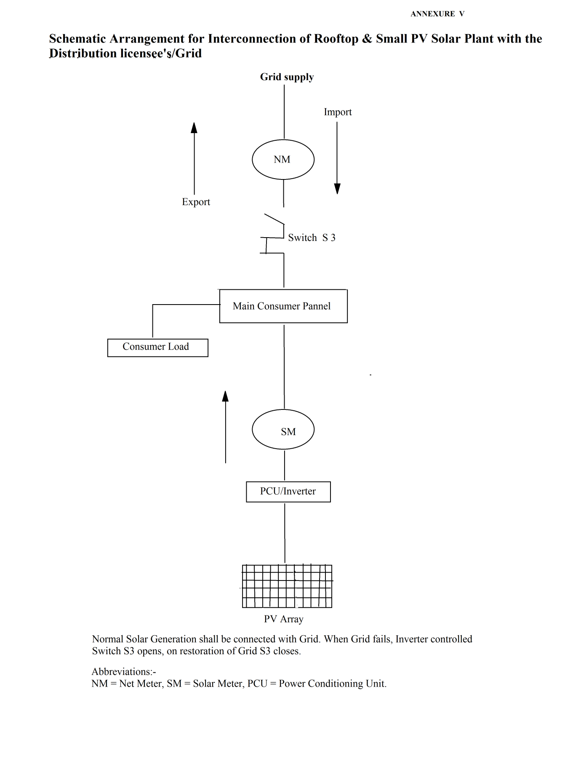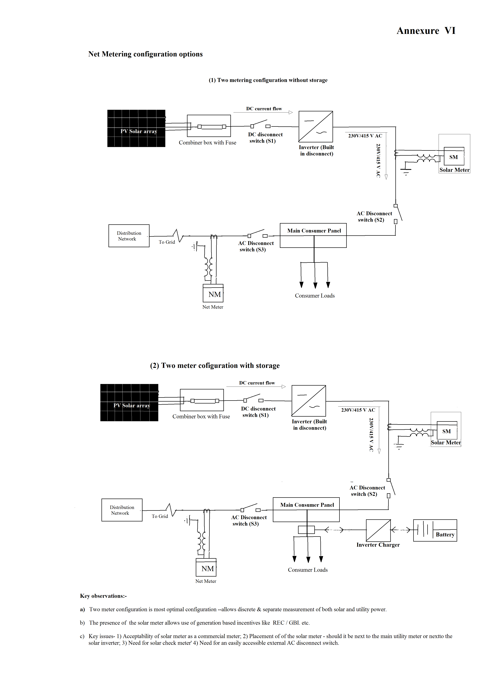

Annexure – VII
Specification for meters for net/gross metering
(a) Meter for Solar Generation Measurements:

Solar Meter Major Technical Parameters
Sl. No. | Technical Parameters | Connectivity at 415V & below voltage level |  |  | Connectivity at above 415 V voltage level
 |  | Whole current meters |  | CT operated | CT-PT Operated
1 | Applicability | Solar plant capacity upto 4 kW | Solar plant capacity above 4 kW and upto 15 kW | Solar Plant Capacity above 15 kW and upto 100 kW | HT/EHV supply
2 | Number of phases and wires | Single Phase, 2 Wire | Three Phase, 4 Wire | Three Phase, 4 Wire | Three Phase, 4 Wire
3 | Measurand(s) | kWh | kWh | kWh, kVAh,kVA, PF | kWh,kVAh, kVA, PF, Max. demand
4 | Standard Voltage and frequency | 240 V, | 3X240V (P-N), 415 V (P-P) 50±5% | 3X240V (P-N), 415V (P-P) 50±5% | 3X63.5 V(P-N), 110 V (P-P) 50±5%
5 | Current Rating | 10-60 | 10-60 | 1 Amp | 1 Amp
6 | Accuracy class | 1.0 | 1.0 | 0.5S | 0.5S
7 | Indian Standard or IEC to which conforming | IS 13779-1999 | IS13779-1999 | IS 14697, IS 13779 | IS 14697, IS 13779
8 | Import-export feature | Forward import | Forward import | Forward import | Forward import
9 | Communication Port/ Protocol | Optical/ DLMS | Optical,RS-232/ DLMS | Optical,RS-232/ DLMS | Optical,RS-232/ DLMS

(b) Meter for Net-Metering Measurements:
Net-Meter Major Technical Parameters
Sl. No. | Technical Parameters | Connectivity at 415V & below voltage level |  |  | Connectivity at above 415 V voltage level
 |  | Whole current meters |  | CT operated | CT-PT Operated
1 | Applicability | Upto 5 kW connected load | Above 5 kW and upto 15 kW connected load | Above 15 kW and upto 100 kW contract demand | HT/EHV supply
2 | Number of phases and wires | Single Phase, 2 Wire | Three Phase, 4 Wire | Three Phase, 4 Wire | Three Phase, 4 Wire
3 | Measurand(s) | kWh | kWh | kWh, kVAh,kVA, PF | kWh,kVAh, kVA, PF, Max. demand
4 | Standard Voltage and frequency | 240 V, 50±5% | 3X240V (P-N), 415 V (P-P) 50±5% | 3X240V (P-N), 415V (P-P) 50±5% | 3X63.5 V(P-N), 110 V (P-P) 50±5%
5 | Current Rating | 10-60 | 10-60 | 1 Amp | 1 Amp
6 | Accuracy class | 1.0 | 1.0 | 0.5S | 0.5S
7 | Indian Standard or IEC to which conforming | IS 13779-1999 | IS13779-1999 | IS 14697, IS 13779 | IS 14697, IS 13779
8 | Import-export feature | Import & Export | Import & Export | Import & Export | Import & Export
9 | Communication Port/ Protocol | Optical/ DLMS | Optical,RS-232/ DLMS | Optical,RS-232/ DLMS | Optical,RS-232/ DLMS

