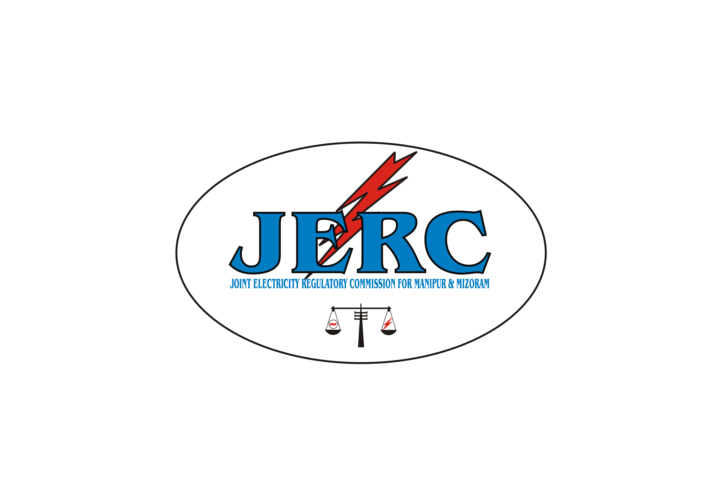
JOINT ELECTRICITY REGULATORY COMMISSION
FOR MANIPUR AND MIZORAM
AIZAWL: : : MIZORAM

D-31, M.G.Road, Upper Khatla
Fax: 0389-2301299
Tel. No. : 0389-2310623
Website: www.jerc.mizoram.gov.in
Email: jerc.mm@gmail

No. G. 12015/3/09-JERC Dated Aizawl, the 29th July, 2010

O R D E R

Present:
1. Mr. H. Bihari Singh, Chairperson,
- Mr. C. Hmingthanzuala, Member.
In the matter of

The Joint Electricity Regulatory Commission for Manipur and Mizoram (Fees, Fines & Charges) Regulations, 2010.

The Commission had earlier published draft of the Joint Electricity Regulatory Commission for Manipur and Mizoram (Fees, Fines & Charges) Regulations, 2010 inviting comments/suggestions/objections from the stakeholders through public notice dated 10th June, 2010.

No response to the above public notice was received till the last date fixed for submission of comments/suggestions/objections, which was 19th July, 2010.

Having considered the draft Regulations carefully, we hereby direct that the Joint Electricity Regulatory Commission for Manipur and Mizoram (Fees, Fines & Charges) Regulations, 2010 as per the notification placed below be published in the Official Gazettes of Manipur and Mizoram.

We give above direction this 29th day of July, 2010 and effective from 1st August, 2010.

Sd/- C. HMINGTHANZUALA Sd/- H. BIHARI SINGH
Member Chairperson

JOINT ELECTRICITY REGULATORY COMMISSION
FOR MANIPUR AND MIZORAM
AIZAWL ::: MIZORAM

N O T I F I C A T I O N

No. G. 12015/3/09- JERC, date 29th July, 2010. In exercise of the powers conferred under sub section (2) of section 181 of the Electricity Act, 2003 and all powers enabling it in that behalf, the Joint Electricity Regulatory Commission for Manipur & Mizoram hereby makes the following Regulations.

1 Short title, commencement and extent

(1) These Regulations may be called the “Joint Electricity Regulatory Commission for Manipur & Mizoram (Fees, Fines & Charges) Regulations, 2010”.
(2) These Regulations shall come into force with effect from 1st August, 2010.
(3) These Regulations extend to the whole of the States of Manipur and Mizoram and shall apply in relation to all matters falling within the jurisdiction of the Commission.

2 Definitions

(1) In these regulations, unless the context otherwise requires:
(i) “Act” means the Electricity Act, 2003 (36 of 2003).
(ii) “Commission” means the Joint Electricity Regulatory Commission for the States of Manipur & Mizoram.
(iii) “Fees” means fees mentioned in schedule 1.
(iv) “Fines and/or charges” refers to Fines and/or charges that Commission is empowered to impose under the Act.
- “Fund” means the fund constituted under section 103 of the Electricity Act 2003.
(vi) “Integrated Utility” means the Mizoram & Manipur Electricity Departments in their present form or the successor entity of the Departments performing one or more of the functions of generation, transmission, distribution and trading after restructuring and/or Corporatisation of the Department(s).

(2) Words or expressions used herein and not defined shall have the meanings respectively assigned to them in the Act and/or JERC for Manipur and Mizoram (Conduct of Business) Regulations, 2010 as the case may be.

3 Fees
(1) Every application/petition made to the Commission shall be accompanied by Fees specified in Schedule 1 of these Regulations.

(2) The Fees payable under these Regulations shall be paid by means of bank draft or pay order, drawn in favour of the ‘the Joint Electricity Regulatory Commission for Manipur & Mizoram’, payable at Aizawl, Mizoram or may be paid in cash, in case the amount does not exceed rupees one thousand.

- The Fees received by the Commission under these Regulations shall be deposited in the bank account of the Fund.

- In case of any inconsistency with the rates, specified in any other Regulations made by the Commission, the fees or charges specified in these Regulations shall prevail.

4 Penalty/Fines and/or Charges

- Imposition of Penalty, Fines and/or Charges

    - Subject to the provisions of the Acts, the Commission may, while deciding any matter or proceeding pending before the Commission or at any other time, initiate a proceeding for imposition of Fines and/or Charges against any person including Integrated Utilities/licensees for non-compliance or violation on their part of the provisions or requirements of the Act or Rules, Regulations or Codes framed under the Act or the directions or orders of the Commission made from time to time.

    - While determining the quantum or extent of the Fines and/or Charges to be imposed, the Commission shall consider, amongst other relevant things, the following:

      - The nature and extent of non-compliance or violation.
      - The wrongful gain or unfair advantage derived as a result of the non-compliance or violation.
      - The loss or degree of harassment caused to any person(s) as a result of the non-compliance or violation.
      - The repetitive nature of the non-compliance or violation.

(c) Before imposing any Fines and/or Charges, the Commission shall give an opportunity to the person upon whom such Fines and/or Charges are proposed to be imposed, to represent against the proposal to impose such Fines and/or Charges and also on the quantum or extent of the Fines and / or charges proposed to be imposed.

- The Commission shall issue a notice to the person specifying the nature of non- compliance or violation on the person’s part and also all upon him to show cause within the time specified in the notice as to why Fines and/or Charges may not be imposed on him for such non-compliance or violation.

(e) Where in reply to the notice, the person admits non-compliance or violation in writing, the Commission shall record it and may impose such Fines and/or
Charges as it may consider fit in the circumstances of the case, subject to the
provisions of the Act.

- If a person to whom a notice has been issued under sub-section (c) fails to show cause or denies non compliance with or violation of any provision of the Act or Rules or Regulations or an Order of the Commission, the Commission may enquire into the matter in such manner as it deems fit.

- The Commission may on being satisfied that no non-compliance or violation of any provision of Act, Rules or Regulations or an order of the Commission has been committed, discharge the notice.

- Procedure for Recovery of Penalty, Fines and / or Charges.

(a) Any Penalty ordered by the Commission under Section 142 and Section146 of the Act or by the adjudicating officer under Section 143 shall be paid within thirty (30) days of the order of the Commission or the adjudicating officer, or within such extended time as may be allowed by the Commission or such adjudicating officer, as the case may be.

(b) The Penalty/Fines and/or Charges shall be payable and the amount shall be deposited in the same manner as provided under Regulations 3(2) and 3(3) of these Regulations.

5 Fees payable on the grant of license

(1) All existing/deemed licensees shall pay the annual Fee for the financial year 2010-11 onwards as specified in the schedule 1 and shall not be required to pay any initial license fee.

(2) All new entrants shall be required to pay initial license Fee and Annual Fee.

(3) All annual Fees commencing from the financial year 2010-11 shall be paid by 15th April each year. And for the financial year 2010-11 it shall be paid within 3(three) months of the effective date of this Regulation.

(4) In case of late payment of annual Fee, interest will be payable on the delayed amount at the rate of 1% per month.

6 Inclusion in tariff
The licensee shall be entitled to take into account any Fee paid by it under these Regulations as an expense in the determination of tariff.

Provided that any Penalty/Fines and/or Charges paid under the provisions of the Act shall not be allowed as an expense in the determination of tariff.

7 Power to amend
The Commission may, at any time, vary, alter, modify or amend any of the provisions of these Regulations by an order to be made by the Commission.

8 Power to remove difficulties

If any difficulty arises in giving effect to the provisions of these Regulations, the Commission may, by general or specific order, direct the licensee to take suitable action, not inconsistent with the provisions of the Act, as may appear necessary for removing the difficulty.

9 Repeal and Saving-

- Save as otherwise provided in these Regulations, the Joint Electricity Regulatory Commission for the States of Manipur & Mizoram (Fees, Fines & Charges) Regulations 2009 is hereby repealed.

(2) Notwithstanding such repeal, all proceedings and actions taken and orders passed by the Commission or by any authority or Committee under the Regulations or the Orders so repealed, exercising or purporting to exercise jurisdiction under such Regulations or Orders shall be deemed to be as good and valid in law as if it has been so taken and made under the relevant provisions of this Regulations or the Order, as the case may be.

By Order of the Commission,

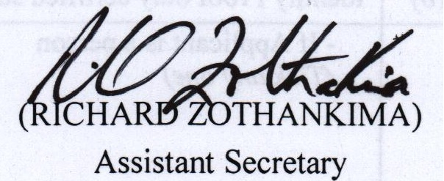

SCHEDULE -1
 | FEES, FINES AND CHARGES
 | Sl.  No | Description | Fees/Fines/Charges
 | 1 | Initial licence fee | Rs. 5,00,000 (Five lakhs)
 | 2 | Annual licensee fees for:  (a) Transmission licensee  (b) Distribution licensee  (c) Trading licensee  (d) Integrated utility | (a) Rs. 3,00,000  (b) Rs 5,00,000  (c) Rs 1,00,000  (d) As fixed by the Commission from time to time.
 | 3 | Adjudication of dispute regarding availability of transmission facility under the second proviso to sub-section (2) of Section 9 under the Act, to be paid by the person who has referred such dispute to the Commission. | Rs.5,000 for the first one MW of transmission capacity sought and Rs.2,000 per MW or part thereof thereafter, subject to a maximum of Rs.45,000
 | 4 | Petition for grant of exemption from license or review petition under Section 13 of the Act. | Fees as may be specified at the time of filing application/ petition subject to minimum of Rs.5,000
 | 5 | Annual fee for the licensee/deemed licensee who has taken exemption from licensee under Section 13 of the Act. | Fees as may be specified at the time of filing petition, subject to a minimum of Rs. 5,000
 | 6 | Application seeking prior approval under Section 17 of the Act. | Rs. 50,000.00
 | 7 | Application for amendment of licensee under Section 18 of the Act  (a) by licensee  (b) by any person other than a licensee | (a) Rs. 1,00,000  (b) Rs. 50,000
 | 8 | Application for revocation of licensee under subsection (2) of Section 19 of the Act.  (a) by licensee  (b) by any person other than a licensee | (a) Rs. 5,00,000  (b) Rs. 1,00,000
 | 9 | (a) Application under Section 35 of the Act for seeking  the use of intervening transmission facilities. | (a) Rs. 50,000
 |  | (b) Adjudication of dispute regarding extent of surplus  capacity under the proviso to Section 35 of the Act. | (b) Rs. 5,00,000
 | 10 | Application for determination of rates, charges, terms and conditions under proviso to sub-section (1) of Section 36 of the Act. | As fixed by the Commission case to case basis
 | 11 | Adjudication of disputes regarding provision of non-discriminatory open access under Section 40 of the Act and Regulations specified thereunder, not covered above:  (a) referred by a licensee or by a generating company  (b) referred by a person who has constructed, maintained and operated a Captive Generating Plant  (c) referred by consumer or its representative | (a) Rs. 5,00,000  (b) Rs.25,000  (c) Rs. 5,000

12 | Adjudication of disputes regarding provision of non-  discriminatory open access under Sub section (2), (3) and (4) of Section 42 of the Act and Regulations specified  hereunder:  (a) Referred by a licensee or by a Generating Company,  other than a Generating Company referred to in 13(a)  (ii) below  (b) Referred by a Generating Company directly connected to  the distribution system of a Distribution Licensee or by  person who has constructed, maintained and operated a  Captive Generating Plant.  (c) Referred by consumer or its representative | (a) Rs. 5,00,000  (b) Rs. 25,000  (c) Rs. 5,000
13 | (a) Determination of tariff under the provisions of clause (a) of sub-section (1) of Section 62, for supply of electricity by a Generating Company to a Distribution Licensee.  (i) Conventional fuel based (coal, oil etc) plant.  (ii) Non-conventional & Renewable Sources of  Energy, including co-generation. | (i) Rs.5,00,000.00  (ii) Rs.10,000.00 for the first 1 MW or part thereof and each additional 1MW will be Rs.3,000.00
13 | (b) Annual/base year determination of tariff for transmission of electricity under the provisions of clause (b) of Sub-section (1) of Section 62.  Provided that Fees are payable whether such determination is upon application by the licensee or by any other person or suo motto determination by the Commission. | (b) Rs.3,00,000.00
13 | (c) Annual/base year determination of tariff for retail sale of electricity under the provisions of clause (d) of Sub-section (1) of Section 62.  Provided that Fees are payable whether such determination is upon application by the Licensee or by any other person or suo motto determination by the Commission. | (c ) Rs.5,00,000
 | (d) Annual/base year determination of tariff for integrated utility/deemed licence. | (d) Rs.5,00,000.00
  Provided that Fees are payable whether such determination is upon application by the licensee or by any other person or suo motto determination by the Commission.
14 | Petition/application for approval of process or price for power purchase or procurement by distribution licensee, finalization of Power Purchase Agreement.  (a) Conventional Source of Energy.  (b) Non conventional | (a) Rs.10,000.00 per MW (minimum Rs.50,000.00 and maximum of Rs.5,00,000.00)  (b) 50% of the above, (a)
15 | Application for determination of variable cost adjustment (VCA) charges. | Rs.50,000
16 | (a) Application for review of Tariff Order or power  purchase agreement or power procurement rate by  licensee.  (b) Application by an institution/ association/ company for  review of Tariff Order or Power Purchase Agreement or  Power Procurement Rate. | - Rs. 1,00,000.00  (b) Rs.35,000.00
 | (c) Application by an individual consumer for review of Tariff Order or Power Purchase Agreement or Power Procurement Rate. | (c) Rs.20,000.00
17 | Application for approval of the schedule of charges of a Distribution Licensee under Section 45 and Section 46 of the Act. | Rs.50,000.00
18 | Settlement of disputes arising under Sub-section (4) & (5) of Section 67 of the Act. | Rs.10,000
19 | Adjudication under clause (f) of sub-section (1) of Section 86 of Act of disputes between licensees and generating companies and between licensees themselves, not covered elsewhere in this schedule. | Rs.5,00,000
20 | Application for review of order passed under clause (f) of sub-section (1) of Section 86 of the Act. | Rs.50,000
21 | Interlocutory application | Rs.5,000
22 | Appeal against the decision of Chief Electrical Inspector | Rs.5,000
23 | Application for review of orders of Commission not covered elsewhere in this schedule. | Rs.20,000.00
24 | Application for inspection of orders/records of the Commission | Rs.100 per case.
25 | Supply of copies of documents/order of the Commission | Rs.2 per page.
26 | Miscellaneous applications i.e. application not covered elsewhere in this schedule.  (a) Applications by licensees  (b) Applications by consumers other than individuals.  (c) Applications by individual consumers and others. | (a) Rs.10,000  (b) Rs.250  (c) Rs.100
27 | Request for inspection on documents permitted to be inspected. | Rs. 200/- per day or part thereof (Rupees Two Hundred)
28 | Request for obtaining certified copies as may be permitted. | Rs. 2/- per page of copy allowed Plus Rs.10/- as Application Fee.
29 | Request for rectification or order on ground of the typographical or clerical error/mistake. | Rs. 100/- (Rupees One Hundred)
30 | Complaint against the working of a utility by the user / consumer. | Rs. 25 (Rupees Twenty Five)
31 | Fines/Penalties for non-compliance or violation of the Act or orders/directives passed by the Commission. | May be levied up to Rs. 1,00,000/- and additionally a daily fine up to Rs.6,000.00 for non-compliance or violations.
32 | Inspection and testing of consumer’s Installation  (a) For L.T. Consumer  (b) For H.T. Consumer | No Charge for first Inspection & Testing  (a) Rs 200/- for every subsequent  test  (b) Rs. 1,000.00 for every subsequent  test
33 | Release of New Connections/Additional load. Licensee shall release supply to an application after the receipt of the complete application, prescribed fees and charges and security  a) Load Security  b) Meter Security  c) Cost of labour  d) Cost of Testing | *** As per prevailing rate of the  State Electricity Department
34 | Transfer of ownership and conversion of services etc.  a) Transfer of ownership  b) Fee for Change of category  c) Conversion from LT single to LT 3-phase and vice-  versa  d) Conversion of HT to LT | *** As per prevailing rate of the  State Electricity Department

*** The Electricity Department may furnish the prevaling

